**Project team #11 - Club Management System**

**Team Members: Ashwini Kasbekar**

**Dev Takle**

**Sanyogeeta Lawande**

**Armin Amirazar**

PROJECT PROPOSAL

**Context**

Club Management System aims at designing database for country club events and activities. The application developed will be useful for interested users and event organizers.

**Scope**

Intended users of this application will be:

* Member: Member can login in the application, view event details, register and provide feedback about events, can create an event, ask for venue and schedule for the event.
* Employee: Employee can manage events, schedules and venues, view member list, handle equipments specific to their events, create Schedules and decide venues for the events..
* Manager: Responsible for managing the entire club. Managers can appoint employees for specific events and activities and grant permission for events.

**Objective**

Club Management System is a software designed with the motive of managing a club. This software system consists of various online registration and management functionalities needed by a country club. It provides various options like member registrations, event details, equipment renting/purchasing etc. This software system assures efficient management and maintains the functioning for a country club.

PROJECT ENVIRONMENT

phpMyAdmin can manage a whole MySQL server as well as a single database. We have decided to use phpMyAdmin(Version information: 4.0.10) for this project. We will be using Eclipse IDE for UI (Version: Oxygen Release (4.7.0)) and JDBC as connectors.

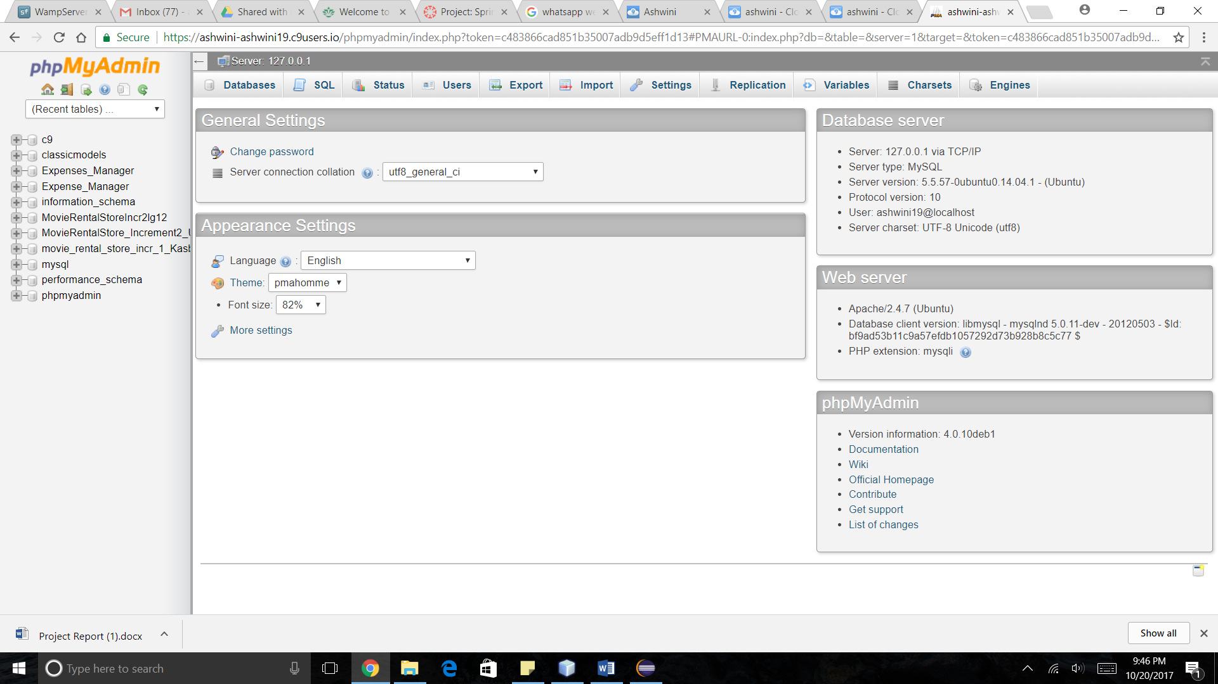

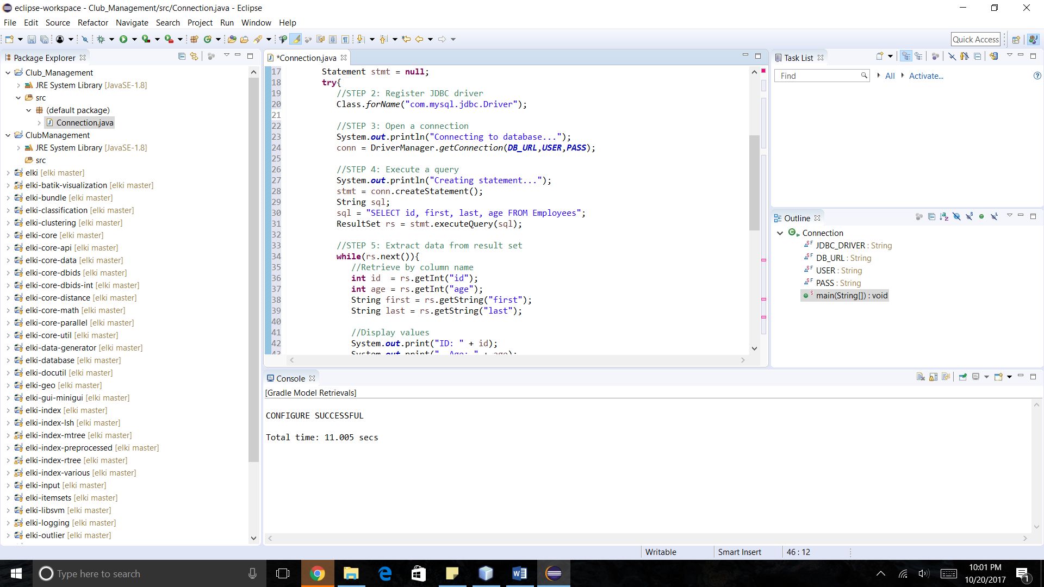

HIGH LEVEL REQUIREMENTS

Initial user roles

|  |  |
| --- | --- |
| **User Role** | **Description** |
| Manager | Assigns Employee to Event. |
| Employee | Manage the assigned Event. |
| Member | Can login into their account, access activities, register for activities and create events |

Initial user story descriptions

|  |  |
| --- | --- |
| **Story ID** | **Story description** |
| US1 | As a Manager, I want to appoint Employee to a particular Event or Activity. |
| US2 | As a Manager, I want to create Activity. |
| US3 | As a Manager, I want to create an Event. |
| US4 | As a Manager, I want to approve Event requested by Member. |
| US5 | As a Manager, I want to notify Members about Event. |
| US6 | As a Manager, I want to view and handle the Inventory. |
| US7 | As a Member, I want to login into my account so that I can view an Activity. |
| US8 | As a Member, I want to login into my account so that I can register for Activity. |
| US9 | As a Member, I want to book a Venue and a slot in Schedule for my Event. |

HIGH LEVEL CONCEPTUAL DESIGN

Entities:

Employee

Manager

Member

Event

Activity

Inventory

Venue

Schedule

Relationships:

Manager appoints Employee.

Manager approves Event.

Manager creates Activity.

Manager creates Event.

Manager handles Inventory

Member registers for Activity.

Member requests Event.

**SPRINT 1**

**REQUIREMENTS**

|  |  |
| --- | --- |
| Story ID | Story description |
| US1 | As a Manager, I want to create Activity so that when the club offers a new Activity, I can add this activity to the database with a unique id, details and category associated with it. An Activity is a weekly recurring event at the club. |
| US2 | As a Member, I want to login using my username and password. |
| US3 | As an Employee, I want to login using my username and password. |
| US4 | As a Manager, I want to add Venue so that it has a capacity associated with it, and is also categorized as outdoor or indoor. |
| US5 | As a Manager, I want to build a Schedule so that I can add club Activities to it with associated Venues. |
| US6 | As a Manager, I want to appoint Employee so that the employee is assigned to a particular activity or event based on the Schedule. |
| US7 | As a Member, I want to register for an Activity based on the schedule and interest. I should be able to view the type of activities offered by the club, as well the days and times on which they are scheduled to happen. |
| US8 | As a Manager, I want to create an Event. |
| US9 | As a Member, I want to book a Venue and a slot in Schedule for my Event. |
| US10 | As a Manager, I want to approve Event requested by Member. |
| US11 | As a Member, I want to request an Event. |
| US12 | As a Manager, I want to notify Members about Activity. |
| US13 | As a Manager, I want to assign Inventory to an Event/Activity. |
| US12 | As an Employee, I want to update Inventory. |

**CONCEPTUAL DESIGN**

Entity: **Activity**

Attributes:

activity_id

activity_name

category

Entity: **Employee**

Attributes:

employee_id

ename [composite]

First_name

Last_name

address [composite]

line1

line2

city

state

zip

email [multi-valued]

phone_no [multi-valued]

Entity: **Venue**

Attributes:

venue_id

venue_name

location_type

opening_time

closing_time

capacity

Entity: **Schedule**

Attributes:

day

time

Entity: **Member**

Attributes:

member_id

member_name [composite]

first_name

last_name

address [composite]

line1

line2

city

state

zip

email [multi-valued]

phone_no [multi-valued]

reg_date

Entity: **Category**

Attributes:

category_id

category_name

Relationship: **Member** registers for an **Activity**

Cardinality: Many to Many

Participation:

Member has partial participation

Activity has partial participation

Relationship: **Activity** has **Venue**

Cardinality: Many to Many

Participation:

Activity has partial participation

Venue has partial participation

Relationship: **Activity** is added to **Schedule**

Cardinality: Many to One

Participation:

Activity has partial participation

Schedule has partial participation

Relationship: **Employee** manages an **Activity**

Cardinality: Many to Many

Participation:

Activity has total participation

Employee has partial participation

Relationship: **Activity** has **Category**

Cardinality: Many to Many

Participation:

Activity has total participation

Category has partial participation

**LOGICAL DESIGN**

Table: **Activity**

Columns:

activity_id

activity_name

Primary key justification: activity_id is unique for every activity

Table: **Employee**

Columns:

employee_id

first_name

last_name

line1

line2

city

state

zip

Primary key justification: employee_id is unique for every employee

Table: **EmployeePhone**

Columns:

employee_id

phone_no

Primary key justification: employee_id and phone_no together will be unique

Table: **EmployeeEmail**

Columns:

employee_id

email

Primary key justification: employee_id and email together will be unique

Table: **Member**

Columns:

id

first_name

last_name

line1

line2

city

state

zip

reg_date

Primary key justification: member_id is unique for every employee

Table: **MemberPhone**

Columns:

id [foreign key; references member_id from Member]

phone_no

Primary key justification: member_id is unique for every employee

Table: **MemberEmail**

Columns:

id [foreign key; references memberid from Member]

email

Primary key justification: member_id and email together will be unique

Table: **Category**

Columns:

category_id

category_name

Primary key justification: category_id is unique for every category

Table: **Venue**

Columns:

id

venue_name

location_type

opening_time

closing_time

capacity

Primary key justification: venue_id is unique for every venue

Table: **ActivitySchedule**

Columns:

id

day_of_week

start_at

end_at

activity_id [foreign key; references id from Activity]

venue_id [foreign key; references id from Venue]

Primary key justification: id is uniquely generated id to indicate a specific instance of an activity

This table represents activity, Schedule and Venue relationship.

Table: **EmployeeActivity**

Columns:

employee_id [foreign key; references id from Employee]

activity_instance_id [foreign key; references id from ActivitySchedule]

Primary key justification: Since Employee and Activity have a many to many relationship we use a cross-reference approach, hence employee_id and activity_instance_id together form a primary key

Table: **ActivityCategory**

Columns:

activity_id [foreign key; references id from Activity]

category_id [foreign key; references id from Category]

Primary key justification: Since Activity and Category have a many to many relationship we use a cross-reference approach, hence activity_id and category_id together form a primary key

Table: **MemberActivity**

Columns:

activity_instance_id [foreign key; references id from ActivitySchedule]

member_id [foreign key; references member_id from Member]

Primary key justification: Since Activity and Member have a many to many relationship we use a cross-reference approach, hence member_id and activity_instance_id together form a primary key

Table: **MemberLogin**

Columns:

member_id [foreign key; references id from Member]

pass

Primary key justification : member_id can uniquely define a row

Table : **EmployeeLogin**

Columns:

employee_id [foreign key; references employee_id from Employee]

pass

Primary key justification : employee_id can uniquely define a row

**SQL QUERIES**

1. Member names for members who have registered for swimming

[**SELECT**](https://ashwini-ashwini19.c9users.io/phpmyadmin/url.php?url=http%3A%2F%2Fdev.mysql.com%2Fdoc%2Frefman%2F5.5%2Fen%2Fselect.html&token=39d12937f07385587fb27f2a55168238) **DISTINCT** [CONCAT_WS](https://ashwini-ashwini19.c9users.io/phpmyadmin/url.php?url=http%3A%2F%2Fdev.mysql.com%2Fdoc%2Frefman%2F5.5%2Fen%2Fstring-functions.html%23function_concat_ws&token=39d12937f07385587fb27f2a55168238)( ' ', m.first_name, m.last_name ) **AS** name

**FROM** Member m

**INNER** **JOIN** MemberActivity ma **ON** ma.member_id [=](https://ashwini-ashwini19.c9users.io/phpmyadmin/url.php?url=http%3A%2F%2Fdev.mysql.com%2Fdoc%2Frefman%2F5.5%2Fen%2Fcomparison-operators.html%23operator_equal&token=39d12937f07385587fb27f2a55168238) m.id

**INNER** **JOIN** ActivitySchedule a **ON** a.id [=](https://ashwini-ashwini19.c9users.io/phpmyadmin/url.php?url=http%3A%2F%2Fdev.mysql.com%2Fdoc%2Frefman%2F5.5%2Fen%2Fcomparison-operators.html%23operator_equal&token=39d12937f07385587fb27f2a55168238) ma.activity_instance_id

**INNER** **JOIN** Activity act **ON** act.id [=](https://ashwini-ashwini19.c9users.io/phpmyadmin/url.php?url=http%3A%2F%2Fdev.mysql.com%2Fdoc%2Frefman%2F5.5%2Fen%2Fcomparison-operators.html%23operator_equal&token=39d12937f07385587fb27f2a55168238) a.activity_id

**WHERE** act.activity_name [=](https://ashwini-ashwini19.c9users.io/phpmyadmin/url.php?url=http%3A%2F%2Fdev.mysql.com%2Fdoc%2Frefman%2F5.5%2Fen%2Fcomparison-operators.html%23operator_equal&token=39d12937f07385587fb27f2a55168238) 'Swimming'

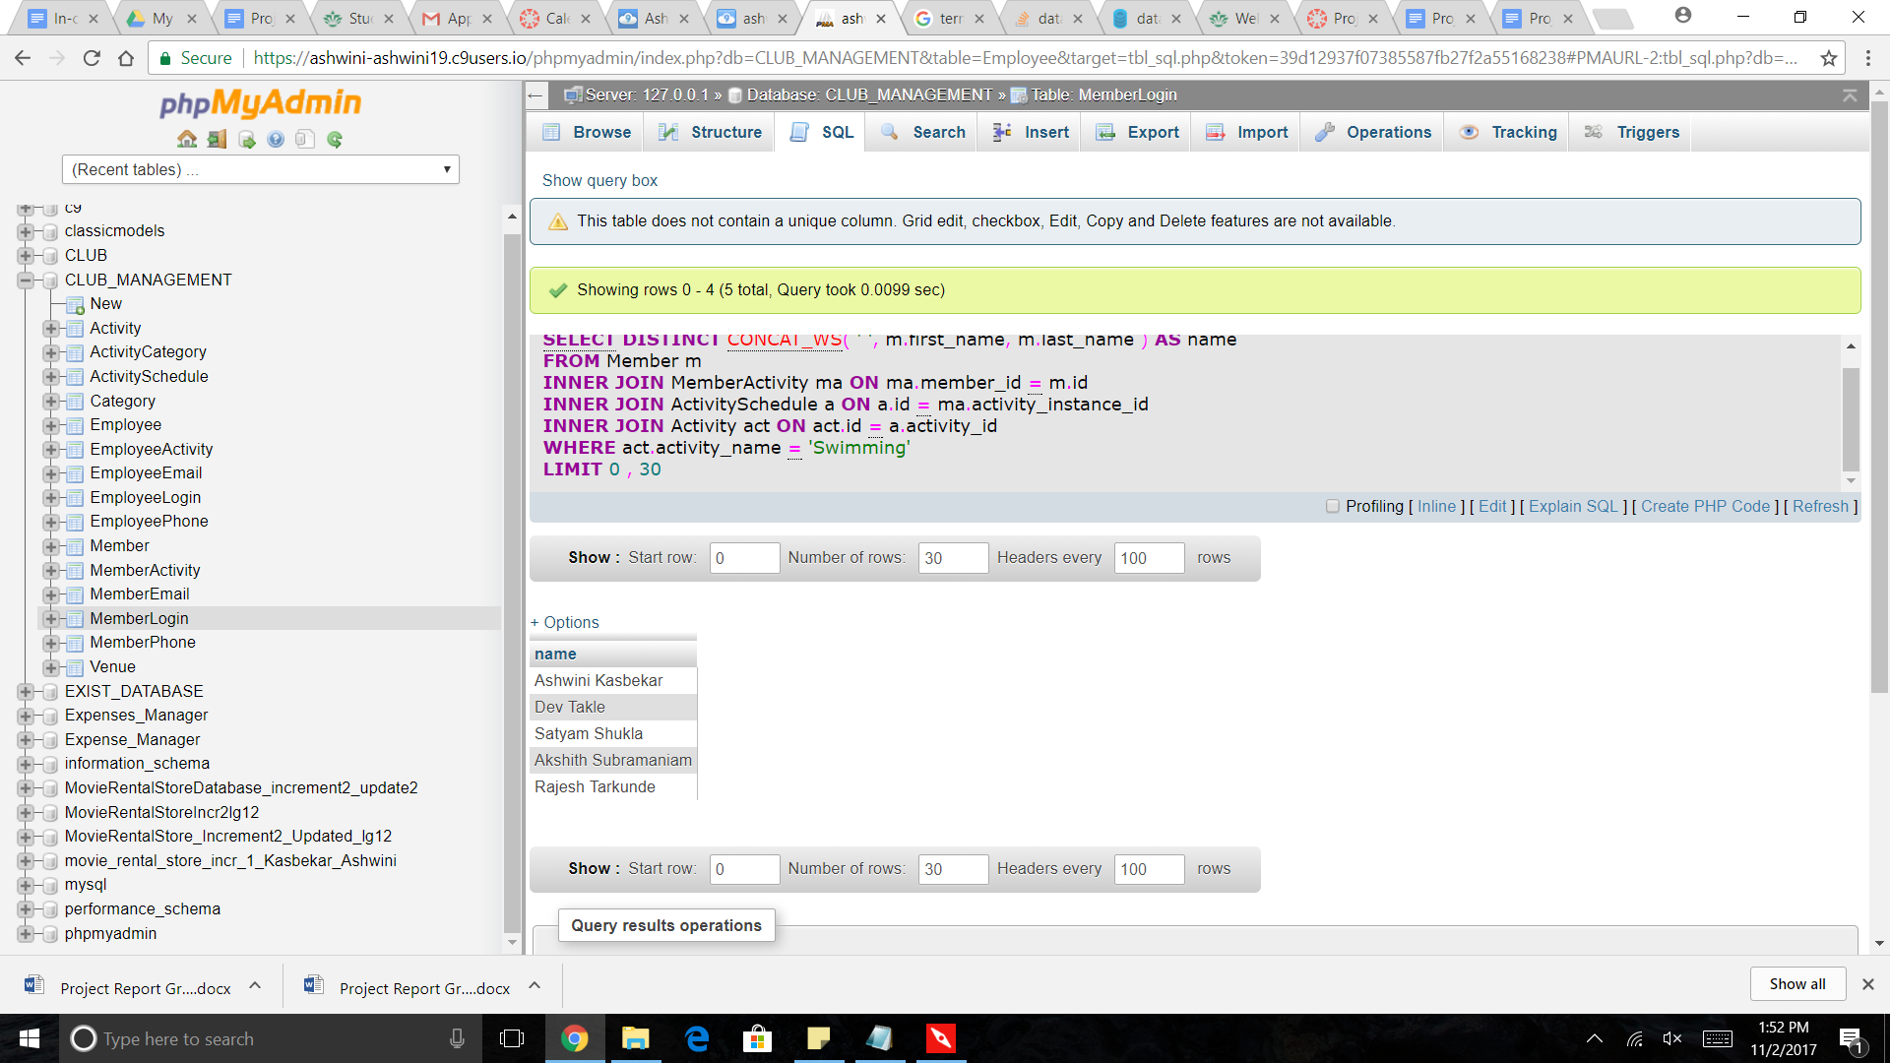

2. Names and Phone numbers of all employees who work on Mondays or Tuesdays

[**SELECT**](https://ashwini-ashwini19.c9users.io/phpmyadmin/url.php?url=http%3A%2F%2Fdev.mysql.com%2Fdoc%2Frefman%2F5.5%2Fen%2Fselect.html&token=39d12937f07385587fb27f2a55168238) [CONCAT](https://ashwini-ashwini19.c9users.io/phpmyadmin/url.php?url=http%3A%2F%2Fdev.mysql.com%2Fdoc%2Frefman%2F5.5%2Fen%2Fstring-functions.html%23function_concat&token=39d12937f07385587fb27f2a55168238)( e.first_name, ' ', e.last_name ) **AS** Name, [GROUP_CONCAT](https://ashwini-ashwini19.c9users.io/phpmyadmin/url.php?url=http%3A%2F%2Fdev.mysql.com%2Fdoc%2Frefman%2F5.5%2Fen%2Fgroup-by-functions.html%23function_group_concat&token=39d12937f07385587fb27f2a55168238)( ep.phone_no ) **AS** 'PhoneNo(s)'

**FROM** Employee e

**INNER** **JOIN** EmployeePhone ep **ON** e.id [=](https://ashwini-ashwini19.c9users.io/phpmyadmin/url.php?url=http%3A%2F%2Fdev.mysql.com%2Fdoc%2Frefman%2F5.5%2Fen%2Fcomparison-operators.html%23operator_equal&token=39d12937f07385587fb27f2a55168238) ep.id

**INNER** **JOIN** EmployeeActivity ea **ON** ep.id [=](https://ashwini-ashwini19.c9users.io/phpmyadmin/url.php?url=http%3A%2F%2Fdev.mysql.com%2Fdoc%2Frefman%2F5.5%2Fen%2Fcomparison-operators.html%23operator_equal&token=39d12937f07385587fb27f2a55168238) ea.employee_id

**INNER** **JOIN** ActivitySchedule actS **ON** ea.activity_instance_id [=](https://ashwini-ashwini19.c9users.io/phpmyadmin/url.php?url=http%3A%2F%2Fdev.mysql.com%2Fdoc%2Frefman%2F5.5%2Fen%2Fcomparison-operators.html%23operator_equal&token=39d12937f07385587fb27f2a55168238) actS.id

**WHERE** actS.day_of_week [=](https://ashwini-ashwini19.c9users.io/phpmyadmin/url.php?url=http%3A%2F%2Fdev.mysql.com%2Fdoc%2Frefman%2F5.5%2Fen%2Fcomparison-operators.html%23operator_equal&token=39d12937f07385587fb27f2a55168238) 'Monday'

[**OR**](https://ashwini-ashwini19.c9users.io/phpmyadmin/url.php?url=http%3A%2F%2Fdev.mysql.com%2Fdoc%2Frefman%2F5.5%2Fen%2Flogical-operators.html%23operator_or&token=39d12937f07385587fb27f2a55168238) actS.day_of_week [=](https://ashwini-ashwini19.c9users.io/phpmyadmin/url.php?url=http%3A%2F%2Fdev.mysql.com%2Fdoc%2Frefman%2F5.5%2Fen%2Fcomparison-operators.html%23operator_equal&token=39d12937f07385587fb27f2a55168238) 'Tuesday'

**GROUP** **BY** (

e.id

)

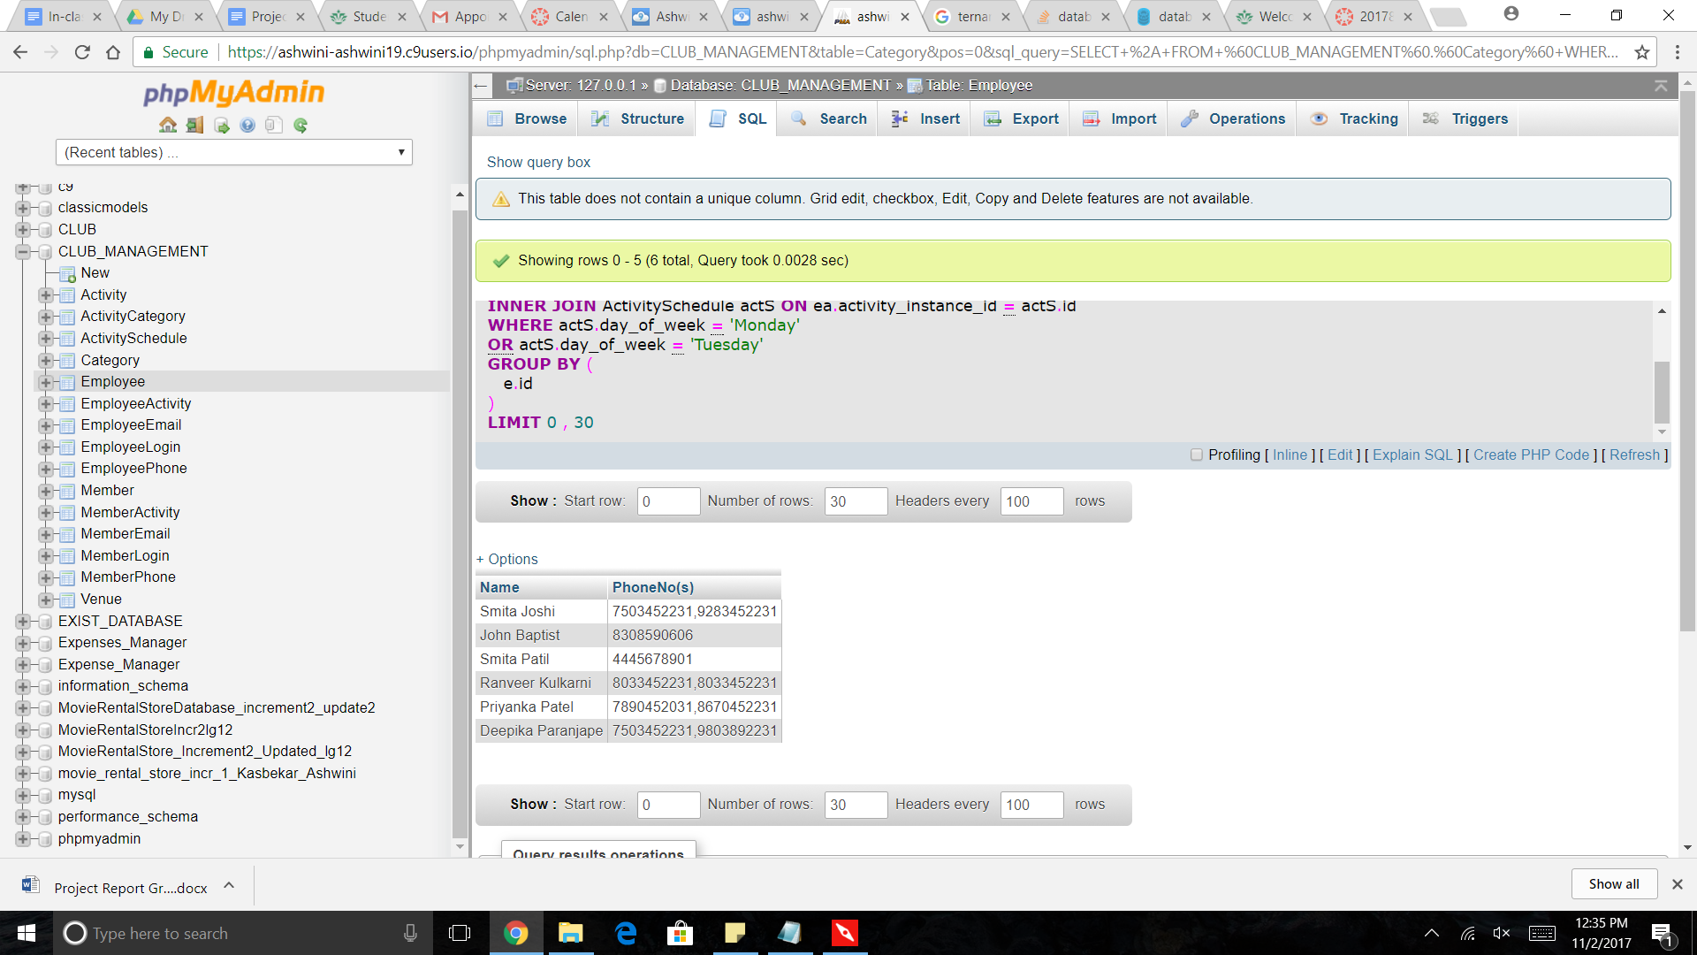

3. Names of members registered for activities managed by employees who are managed by Pablo Escobar

[**SELECT**](https://ashwini-ashwini19.c9users.io/phpmyadmin/url.php?url=http%3A%2F%2Fdev.mysql.com%2Fdoc%2Frefman%2F5.5%2Fen%2Fselect.html&token=39d12937f07385587fb27f2a55168238) m.id, [CONCAT](https://ashwini-ashwini19.c9users.io/phpmyadmin/url.php?url=http%3A%2F%2Fdev.mysql.com%2Fdoc%2Frefman%2F5.5%2Fen%2Fstring-functions.html%23function_concat&token=39d12937f07385587fb27f2a55168238)( m.first_name, ' ', m.last_name ) **AS** 'Name'

**FROM** Member m

**INNER** **JOIN** (

[**SELECT**](https://ashwini-ashwini19.c9users.io/phpmyadmin/url.php?url=http%3A%2F%2Fdev.mysql.com%2Fdoc%2Frefman%2F5.5%2Fen%2Fselect.html&token=39d12937f07385587fb27f2a55168238) **DISTINCT** ma.member_id

**FROM** MemberActivity ma

**INNER** **JOIN** (

[**SELECT**](https://ashwini-ashwini19.c9users.io/phpmyadmin/url.php?url=http%3A%2F%2Fdev.mysql.com%2Fdoc%2Frefman%2F5.5%2Fen%2Fselect.html&token=39d12937f07385587fb27f2a55168238) *

**FROM** EmployeeActivity ea

**INNER** **JOIN** (

[**SELECT**](https://ashwini-ashwini19.c9users.io/phpmyadmin/url.php?url=http%3A%2F%2Fdev.mysql.com%2Fdoc%2Frefman%2F5.5%2Fen%2Fselect.html&token=39d12937f07385587fb27f2a55168238) *

**FROM** Employee e

**WHERE** e.reportsTo [=](https://ashwini-ashwini19.c9users.io/phpmyadmin/url.php?url=http%3A%2F%2Fdev.mysql.com%2Fdoc%2Frefman%2F5.5%2Fen%2Fcomparison-operators.html%23operator_equal&token=39d12937f07385587fb27f2a55168238) (

[**SELECT**](https://ashwini-ashwini19.c9users.io/phpmyadmin/url.php?url=http%3A%2F%2Fdev.mysql.com%2Fdoc%2Frefman%2F5.5%2Fen%2Fselect.html&token=39d12937f07385587fb27f2a55168238) id

**FROM** Employee e1

**WHERE** e1.first_name [=](https://ashwini-ashwini19.c9users.io/phpmyadmin/url.php?url=http%3A%2F%2Fdev.mysql.com%2Fdoc%2Frefman%2F5.5%2Fen%2Fcomparison-operators.html%23operator_equal&token=39d12937f07385587fb27f2a55168238) 'Pablo'

[**AND**](https://ashwini-ashwini19.c9users.io/phpmyadmin/url.php?url=http%3A%2F%2Fdev.mysql.com%2Fdoc%2Frefman%2F5.5%2Fen%2Flogical-operators.html%23operator_and&token=39d12937f07385587fb27f2a55168238) e1.last_name [=](https://ashwini-ashwini19.c9users.io/phpmyadmin/url.php?url=http%3A%2F%2Fdev.mysql.com%2Fdoc%2Frefman%2F5.5%2Fen%2Fcomparison-operators.html%23operator_equal&token=39d12937f07385587fb27f2a55168238) 'Escobar'

)

) **AS** inner1 **ON** ea.employee_id [=](https://ashwini-ashwini19.c9users.io/phpmyadmin/url.php?url=http%3A%2F%2Fdev.mysql.com%2Fdoc%2Frefman%2F5.5%2Fen%2Fcomparison-operators.html%23operator_equal&token=39d12937f07385587fb27f2a55168238) inner1.id

) **AS** inner2

**USING** ( activity_instance_id )

) **AS** inner3 **ON** m.id [=](https://ashwini-ashwini19.c9users.io/phpmyadmin/url.php?url=http%3A%2F%2Fdev.mysql.com%2Fdoc%2Frefman%2F5.5%2Fen%2Fcomparison-operators.html%23operator_equal&token=39d12937f07385587fb27f2a55168238) inner3.member_id

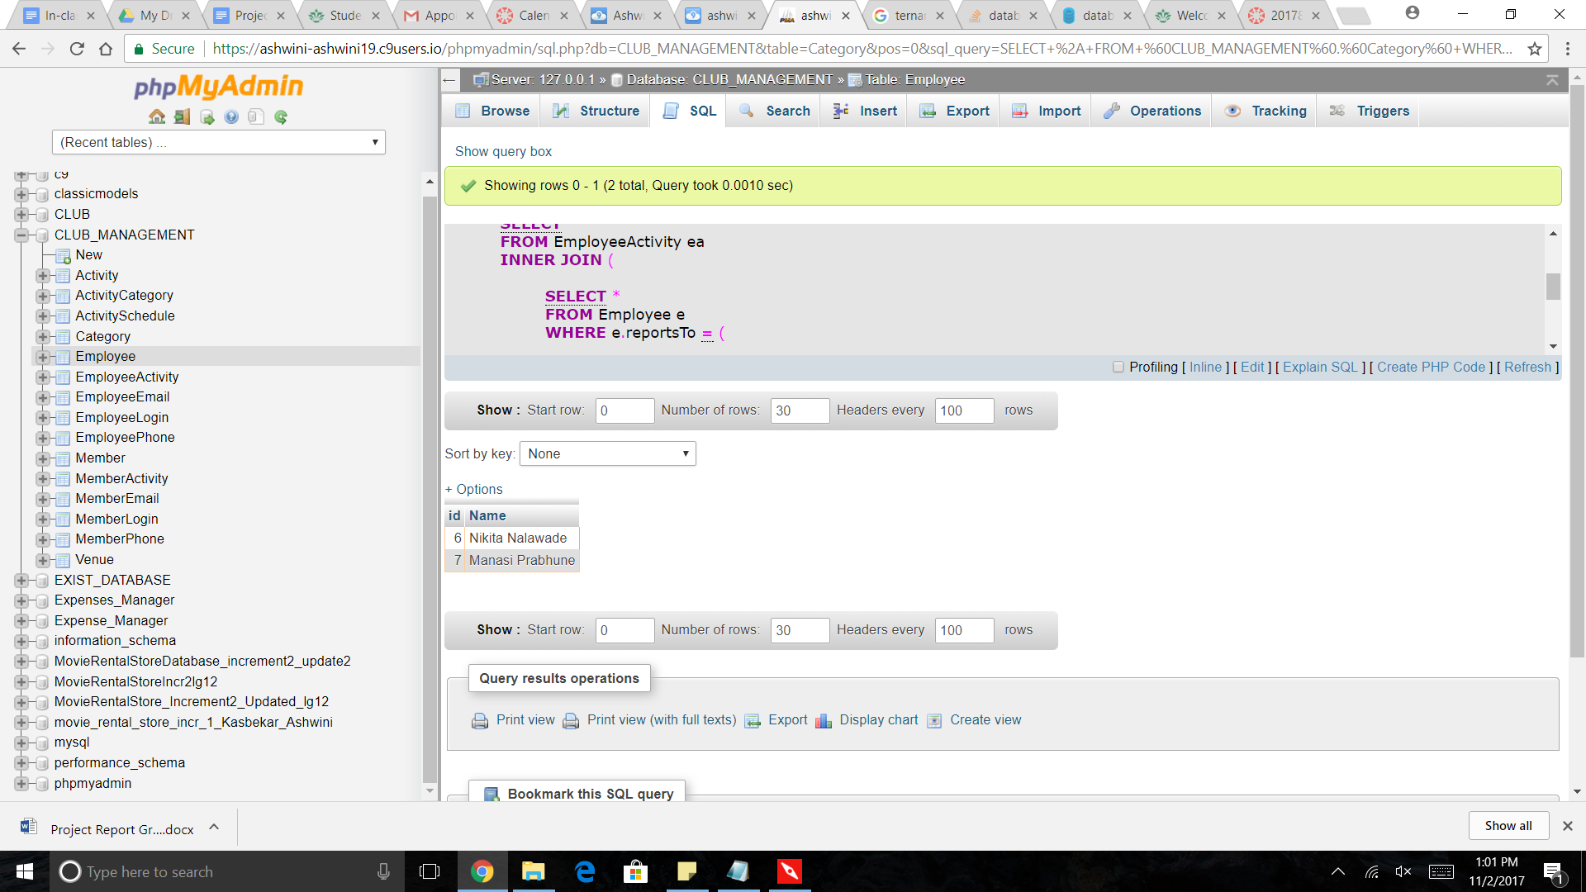

**SPRINT 2**

**REQUIREMENTS**

|  |  |
| --- | --- |
| Story ID | Story description |
| US1 | As a Manager, I want to create Activity  When the club offers a new Activity, Manager can add this activity to the database with a unique id, details and category associated with it. An Activity is a weekly recurring event at the club. |
| US2 | As a Member, I want to login using my username and password. |
| US3 | As an Employee, I want to login using my username and password. |
| US4 | As a Manager, I want to add Venue  Venue has a capacity associated with it, and it is also categorized as outdoor or indoor. |
| US5 | As a Manager, I want to build a Schedule  Manager can add club Activities to schedule with associated Venues and times. |
| US6 | As a Manager, I want to appoint Employee.  The employee is assigned to a particular activity or event based on the Schedule. |
| US7 | As a Member, I want to register for an Activity  The Member registers to the Activity based on the schedule and interest. He should be able to view the type of activities offered by the club, as well the days and times on which they are scheduled to happen. |
| US8 | As a Manager, I want to create an Event  The Event should be created with a Category so that whenever a new event is created by the club for a particular date, members can register for it. |
| US9 | As a Member, I want to request an Event. |
| US10 | As a Member, I want to book a Venue for my Event. |
| US11 | As a Manager, I want to approve Event requested by Member  The Event is added to Event Schedule after it has been approved. |
| US13 | As a Manager, I want to assign Inventory to an Event/Activity. |
| US14 | As an Employee, I want to update Inventory. |

**CONCEPTUAL DESIGN**

Entity: **Activity**

Attributes:

activity_name

category

Entity: **DayOfWeek**

Attributes:

day_of_week

Entity: **Employee**

Attributes:

ename [composite]

first_name

last_name

address [composite]

line1

line2

city

state

zip

email [multi-valued]

phone_no [multi-valued]

Entity: **Venue**

Attributes:

venue_name

location_type

opening_time

closing_time

capacity

Entity: **Schedule**

Attributes:

day

time

Entity: **Member**

Attributes:

member_name [composite]

first_name

last_name

address [composite]

line1

line2

city

state

zip

email [multi-valued]

phone_no [multi-valued]

reg_date

Entity: **Category**

Attributes:

category_name

Entity : **Event**

Attributes :

event_name

event_date

start_at

end_at

venue

Relationship: **Member** registers for an **Activity**

Cardinality: Many to Many

Participation:

Member has partial participation

Activity has partial participation

Relationship: **Activity** has **Venue**

Cardinality: Many to Many

Participation:

Activity has total participation

Venue has partial participation

Relationship: **Activity** is added to **Schedule**

Cardinality: Many to One

Participation:

Activity has partial participation

Schedule has partial participation

Relationship: **Employee** manages an **Activity**

Cardinality: Many to Many

Participation:

Activity has total participation

Employee has partial participation

Relationship: **Activity** has **Category**

Cardinality: Many to Many

Participation:

Activity has total participation

Category has partial participation

Relationship: **Member** creates **Event**

Cardinality: One to Many

Participation:

Member has partial participation

Event has partial participation

Relationship: **Event** has **Venue**

Cardinality: Many to One

Participation:

Event has total participation

Venue has partial participation

Relationship: **Employee** manages **Event**

Cardinality: Many to Many

Participation:

Employee has partial participation.

Event has total participation.

Note:

1. Activity_name and Activity_id is the name and id of activity of a particular Category (for ex. Badminton (with id 1) comes under category Sports).
2. Activity_instance_id is the id for a particular activity with a Schedule and Venue

(ex. Activity Badminton taking place on Monday during 4:00 to 5:00 at Court1 will have activity_instance_id as 1 likewise Activity Badminton taking place on Tuesday during 5:00 to 6:00 will have activity_instance_id as 2 etc ). Members register for a particular activity_instance and Employees are assigned for a particular activity_instance

3. Manager is the creator of Events organized by Club.

**LOGICAL DESIGN**

Table: **Activity**

Columns:

id

activity_name

Primary key justification: id is unique for every activity

Table: **DayOfWeek**

Columns:

id

day_of_week

Primary key justification: id is unique to identify a particular day

Table: **Employee**

Columns:

id

first_name

last_name

line1

line2

city

state

zip

Primary key justification: id is unique for every employee

Table: **EmployeePhone**

Columns:

id[foreign_key; references id in Employee]

phone_no

Primary key justification: employee_id and phone_no together will be unique

Table: **EmployeeEmail**

Columns:

id[foreign_key; references id in Employee]

email

Primary key justification: employee_id and email together will be unique

Table: **Member**

Columns:

id

first_name

last_name

line1

line2

city

state

zip

reg_date

Primary key justification: member_id is unique for every member

Table: **MemberPhone**

Columns:

id [foreign key; references id from Member]

phone_no

Primary key justification: member_id is unique for every member

Table: **MemberEmail**

Columns:

id [foreign key; references id from Member]

email

Primary key justification: member_id and email together will be unique

Table: **Category**

Columns:

id

category_name

Primary key justification: id is unique for every category

Table: **Venue**

Columns:

id

venue_name

location_type

opening_time

closing_time

capacity

Primary key justification: id is unique for every venue

Table: **ActivitySchedule**

Columns:

id

day_of_week [foreign_key; references id from DayOfWeek]

start_at

end_at

activity_id [foreign key; references id from Activity]

venue_id [foreign key; references id from Venue]

Primary key justification: id is uniquely generated id to indicate a specific instance of an activity

This table represents activity, Schedule and Venue relationship.

Table: **EmployeeActivity**

Columns:

employee_id [foreign key; references id from Employee]

activity_instance_id [foreign key; references id from ActivitySchedule]

Primary key justification: Since Employee and Activity have a many to many relationship we use a cross-reference approach, hence employee_id and activity_instance_id together form a primary key

Table: **ActivityCategory**

Columns:

activity_id [foreign key; references id from Activity]

category_id [foreign key; references id from Category]

Primary key justification: Since Activity and Category have a many to many relationship we use a cross-reference approach, hence activity_id and category_id together form a primary key

Table: **MemberActivity**

Columns:

member_id [foreign key; references id from Member]

activity_instance_id [foreign key; references id from ActivitySchedule]

Primary key justification: Since Activity and Member have a many to many relationship we use a cross-reference approach, hence member_id and activity_instance_id together form a primary key.

Table: **MemberLogin**

Columns:

member_id [foreign key; references id from Member]

pass

Primary key justification : member_id can uniquely define a row

Table : **EmployeeLogin**

Columns:

employee_id [foreign key; references id from Employee]

pass

Primary key justification : employee_id can uniquely define a row

Table : **Event**

Columns:

id

name

start_time

end_time

event_date

venue_id[foreign key; references id in Venue]

Primary key justification :id is unique for every venue

Table: **MemberEvent**

Columns:

member_id[foreign key; references id in Member table]

event_id[foreign key;references id in Event table]

Primary key: member_id and event_id are unique together

Table: **EmployeeEvent**

Columns:

employee_id[foreign key; references id in Employee table]

event_id[foreign key;references id in Event table]

Primary key: employee_id and event_id are unique together

VIEW

1. View to obtain details of outdoor activities

**CREATE** **VIEW** OutdoorActivityDetails **AS** [**SELECT**](https://ashwini-ashwini19.c9users.io/phpmyadmin/url.php?url=http%3A%2F%2Fdev.mysql.com%2Fdoc%2Frefman%2F5.5%2Fen%2Fselect.html&token=3b3639a481acf2d9b1ad2e176360ca74) **DISTINCT** a.activity_name, dow.day_of_week, actS.start_at, actS.end_at, v.venue_name

**FROM** Activity a

**INNER** **JOIN** ActivitySchedule actS **ON** a.id [=](https://ashwini-ashwini19.c9users.io/phpmyadmin/url.php?url=http%3A%2F%2Fdev.mysql.com%2Fdoc%2Frefman%2F5.5%2Fen%2Fcomparison-operators.html%23operator_equal&token=3b3639a481acf2d9b1ad2e176360ca74) actS.activity_id

**INNER** **JOIN** DayOfWeek dow **ON** dow.id [=](https://ashwini-ashwini19.c9users.io/phpmyadmin/url.php?url=http%3A%2F%2Fdev.mysql.com%2Fdoc%2Frefman%2F5.5%2Fen%2Fcomparison-operators.html%23operator_equal&token=3b3639a481acf2d9b1ad2e176360ca74) actS.day_of_week

**INNER** **JOIN** Venue v **ON** v.id [=](https://ashwini-ashwini19.c9users.io/phpmyadmin/url.php?url=http%3A%2F%2Fdev.mysql.com%2Fdoc%2Frefman%2F5.5%2Fen%2Fcomparison-operators.html%23operator_equal&token=3b3639a481acf2d9b1ad2e176360ca74) actS.venue_id

**WHERE** v.location_type [=](https://ashwini-ashwini19.c9users.io/phpmyadmin/url.php?url=http%3A%2F%2Fdev.mysql.com%2Fdoc%2Frefman%2F5.5%2Fen%2Fcomparison-operators.html%23operator_equal&token=3b3639a481acf2d9b1ad2e176360ca74) 'outdoor'

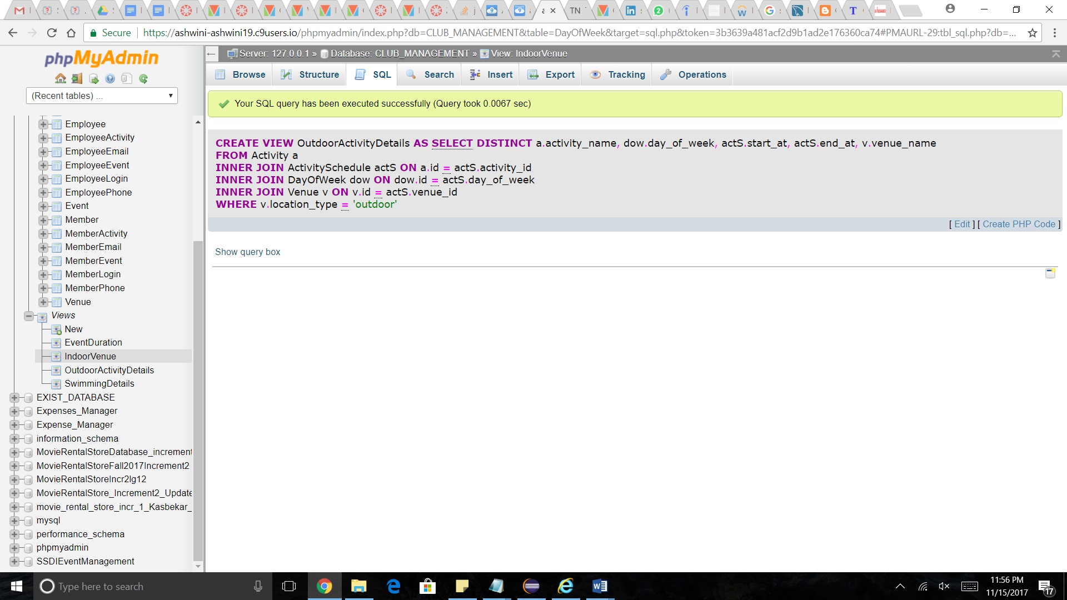

[**SELECT**](https://ashwini-ashwini19.c9users.io/phpmyadmin/url.php?url=http%3A%2F%2Fdev.mysql.com%2Fdoc%2Frefman%2F5.5%2Fen%2Fselect.html&token=3b3639a481acf2d9b1ad2e176360ca74) *

**FROM** `OutdoorActivityDetails`

**LIMIT** 0 , 30

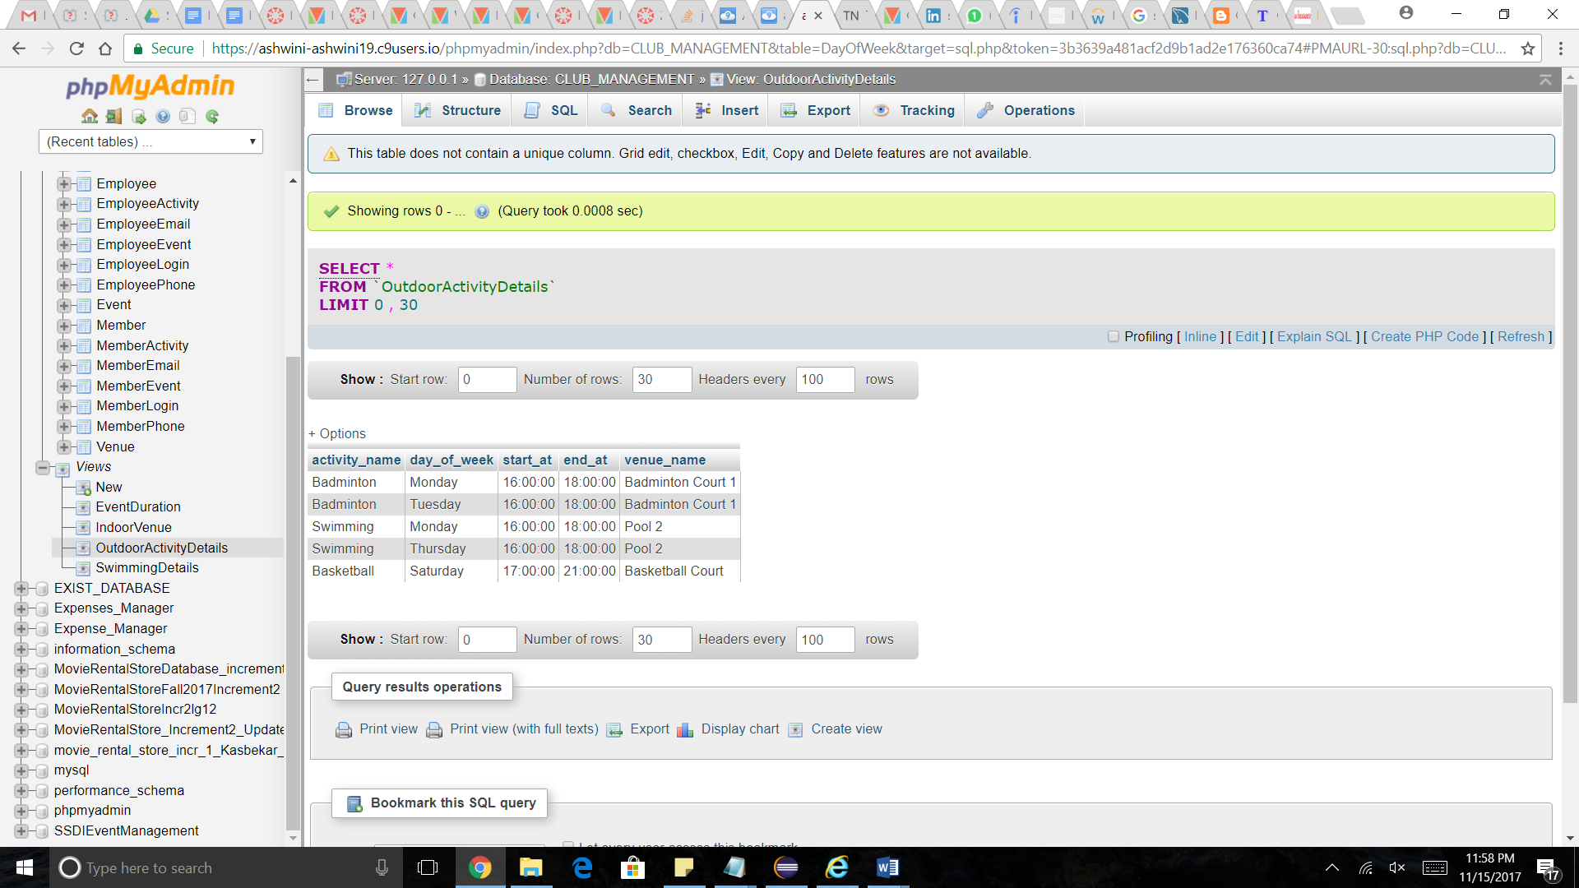

2. View EventDuration to obtain the duration and details of an Event

[**CREATE VIEW**](https://ashwini-ashwini19.c9users.io/phpmyadmin/url.php?url=http%3A%2F%2Fdev.mysql.com%2Fdoc%2Frefman%2F5.5%2Fen%2Fcreate-view.html&token=3b3639a481acf2d9b1ad2e176360ca74) **EventDuration AS** [**SELECT**](https://ashwini-ashwini19.c9users.io/phpmyadmin/url.php?url=http%3A%2F%2Fdev.mysql.com%2Fdoc%2Frefman%2F5.5%2Fen%2Fselect.html&token=3b3639a481acf2d9b1ad2e176360ca74) **DISTINCT e.name, e.event_date, e.start_at,** [**TIMEDIFF**](https://ashwini-ashwini19.c9users.io/phpmyadmin/url.php?url=http%3A%2F%2Fdev.mysql.com%2Fdoc%2Frefman%2F5.5%2Fen%2Fdate-and-time-functions.html%23function_timediff&token=3b3639a481acf2d9b1ad2e176360ca74)**( e.end_at, e.start_at ) AS duration, v.venue_name**

**FROM Event e**

**INNER JOIN Venue v ON e.venue_id** [**=**](https://ashwini-ashwini19.c9users.io/phpmyadmin/url.php?url=http%3A%2F%2Fdev.mysql.com%2Fdoc%2Frefman%2F5.5%2Fen%2Fcomparison-operators.html%23operator_equal&token=3b3639a481acf2d9b1ad2e176360ca74) **v.id**

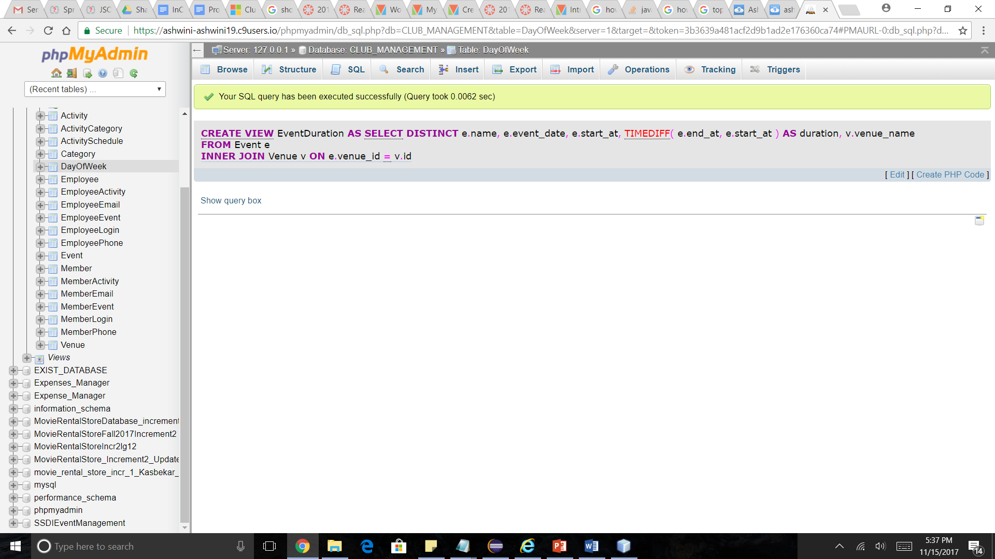

[**SELECT**](https://ashwini-ashwini19.c9users.io/phpmyadmin/url.php?url=http%3A%2F%2Fdev.mysql.com%2Fdoc%2Frefman%2F5.5%2Fen%2Fselect.html&token=3b3639a481acf2d9b1ad2e176360ca74) **\***

**FROM `EventDuration`**

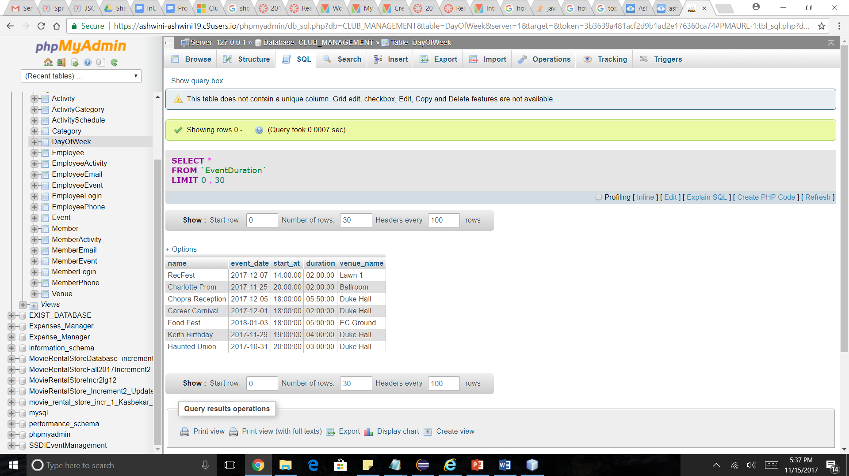

**3. View to obtain Venue details for indoor Venue type**

create view IndoorVenue as

select venue_name, capacity, opening_time, closing_time

from Venue

where location_type='indoor';

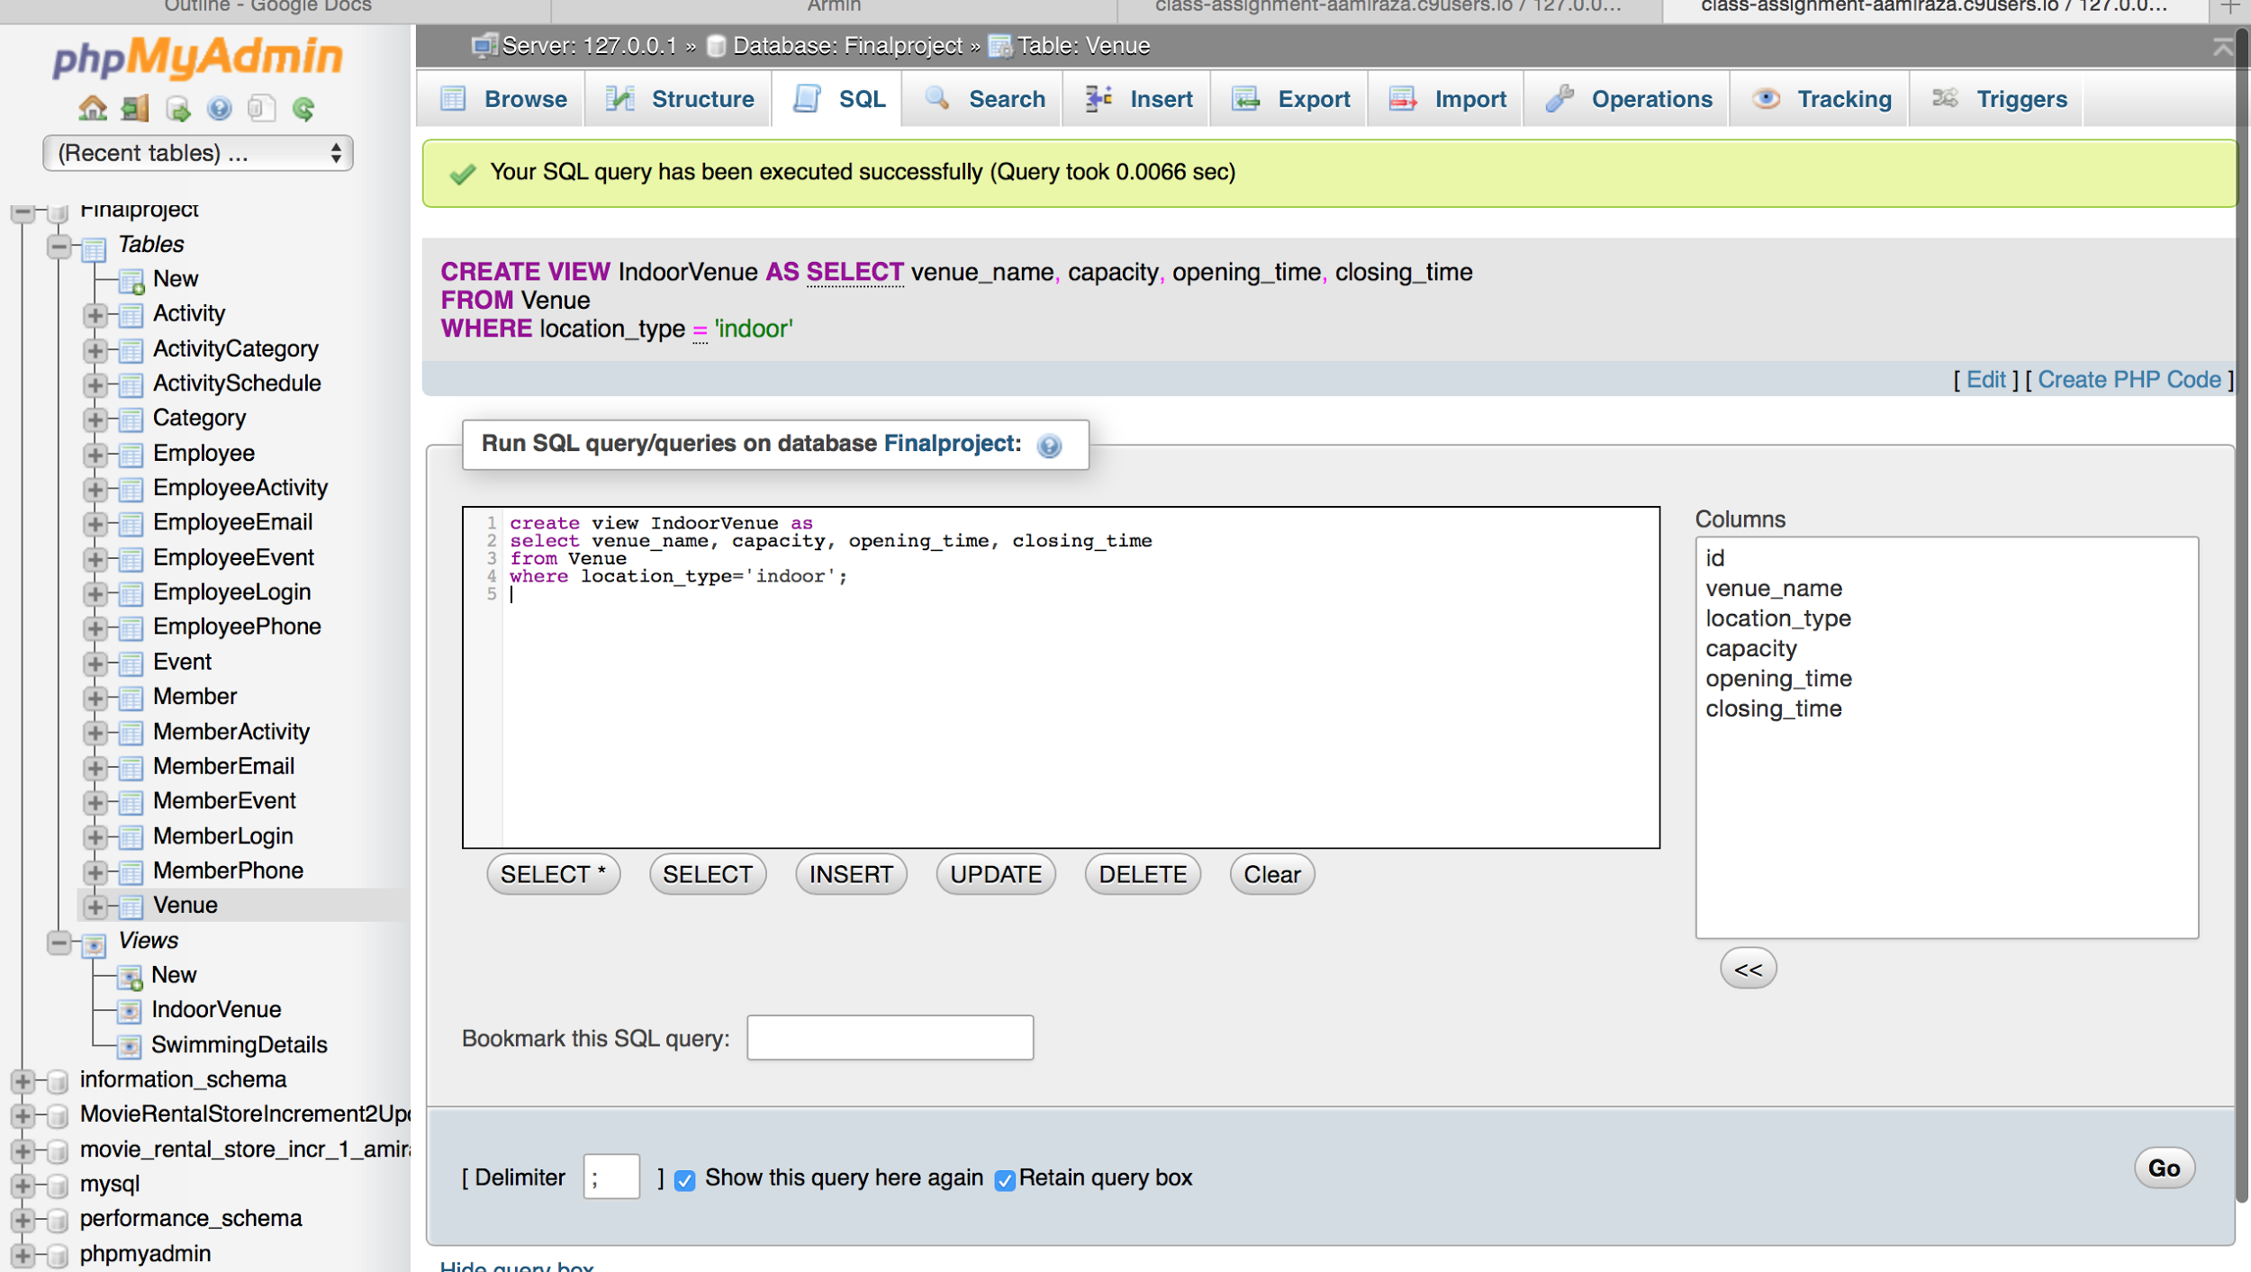

select *

from IndoorVenue

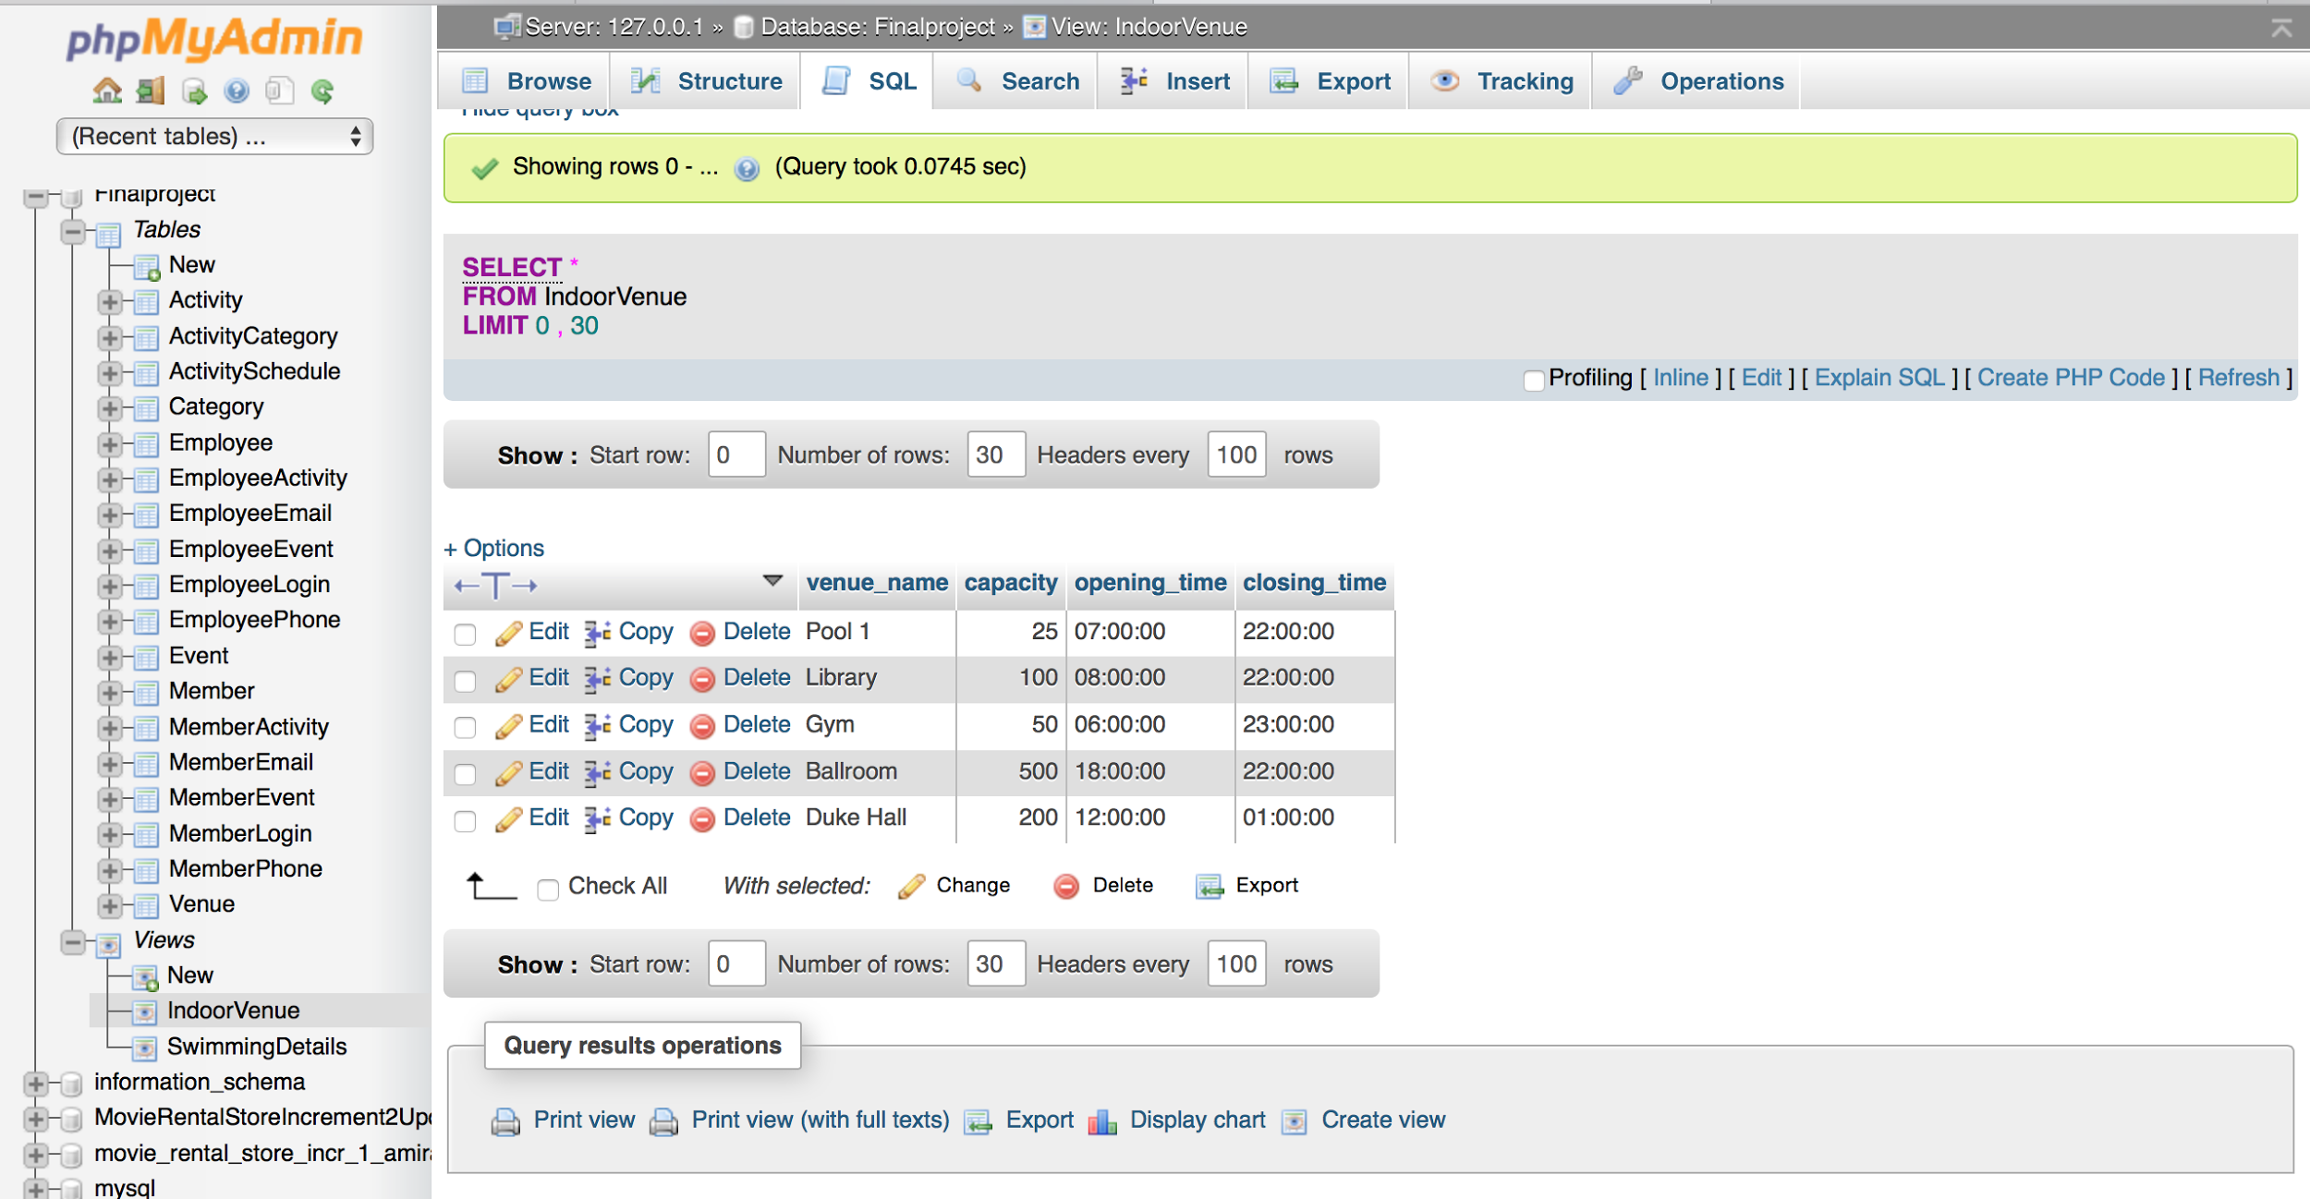

Procedures

Procedure to find the names and phone numbers of Employees working on a particular day

[**CREATE** **PROCEDURE**](https://ashwini-ashwini19.c9users.io/phpmyadmin/url.php?url=http%3A%2F%2Fdev.mysql.com%2Fdoc%2Frefman%2F5.5%2Fen%2Fcreate-procedure.html&token=3b3639a481acf2d9b1ad2e176360ca74) EmployeesWorkingOn( [**IN**](https://ashwini-ashwini19.c9users.io/phpmyadmin/url.php?url=http%3A%2F%2Fdev.mysql.com%2Fdoc%2Frefman%2F5.5%2Fen%2Fcomparison-operators.html%23function_in&token=3b3639a481acf2d9b1ad2e176360ca74) [**DAY**](https://ashwini-ashwini19.c9users.io/phpmyadmin/url.php?url=http%3A%2F%2Fdev.mysql.com%2Fdoc%2Frefman%2F5.5%2Fen%2Fdate-and-time-functions.html%23function_day&token=3b3639a481acf2d9b1ad2e176360ca74) VARCHAR( 25 ) ) **BEGIN** [**SELECT**](https://ashwini-ashwini19.c9users.io/phpmyadmin/url.php?url=http%3A%2F%2Fdev.mysql.com%2Fdoc%2Frefman%2F5.5%2Fen%2Fselect.html&token=3b3639a481acf2d9b1ad2e176360ca74) [CONCAT](https://ashwini-ashwini19.c9users.io/phpmyadmin/url.php?url=http%3A%2F%2Fdev.mysql.com%2Fdoc%2Frefman%2F5.5%2Fen%2Fstring-functions.html%23function_concat&token=3b3639a481acf2d9b1ad2e176360ca74)( e.first_name, ' ', e.last_name ) **AS** Name, [GROUP_CONCAT](https://ashwini-ashwini19.c9users.io/phpmyadmin/url.php?url=http%3A%2F%2Fdev.mysql.com%2Fdoc%2Frefman%2F5.5%2Fen%2Fgroup-by-functions.html%23function_group_concat&token=3b3639a481acf2d9b1ad2e176360ca74)(ep.phone_no ) **AS** 'PhoneNo(s)'

**FROM** Employee e

**INNER** **JOIN** EmployeePhone ep **ON** e.id [=](https://ashwini-ashwini19.c9users.io/phpmyadmin/url.php?url=http%3A%2F%2Fdev.mysql.com%2Fdoc%2Frefman%2F5.5%2Fen%2Fcomparison-operators.html%23operator_equal&token=3b3639a481acf2d9b1ad2e176360ca74) ep.id

**INNER** **JOIN** EmployeeActivity ea **ON** ep.id [=](https://ashwini-ashwini19.c9users.io/phpmyadmin/url.php?url=http%3A%2F%2Fdev.mysql.com%2Fdoc%2Frefman%2F5.5%2Fen%2Fcomparison-operators.html%23operator_equal&token=3b3639a481acf2d9b1ad2e176360ca74) ea.employee_id

**INNER** **JOIN** ActivitySchedule actS **ON** ea.activity_instance_id [=](https://ashwini-ashwini19.c9users.io/phpmyadmin/url.php?url=http%3A%2F%2Fdev.mysql.com%2Fdoc%2Frefman%2F5.5%2Fen%2Fcomparison-operators.html%23operator_equal&token=3b3639a481acf2d9b1ad2e176360ca74) actS.id

**INNER** **JOIN** DayOfWeek dw **ON** actS.day_of_week [=](https://ashwini-ashwini19.c9users.io/phpmyadmin/url.php?url=http%3A%2F%2Fdev.mysql.com%2Fdoc%2Frefman%2F5.5%2Fen%2Fcomparison-operators.html%23operator_equal&token=3b3639a481acf2d9b1ad2e176360ca74) dw.id

**WHERE** dw.day_of_week [=](https://ashwini-ashwini19.c9users.io/phpmyadmin/url.php?url=http%3A%2F%2Fdev.mysql.com%2Fdoc%2Frefman%2F5.5%2Fen%2Fcomparison-operators.html%23operator_equal&token=3b3639a481acf2d9b1ad2e176360ca74)

[**DAY**](https://ashwini-ashwini19.c9users.io/phpmyadmin/url.php?url=http%3A%2F%2Fdev.mysql.com%2Fdoc%2Frefman%2F5.5%2Fen%2Fdate-and-time-functions.html%23function_day&token=3b3639a481acf2d9b1ad2e176360ca74)

**GROUP** **BY** (

e.id

);

**END**

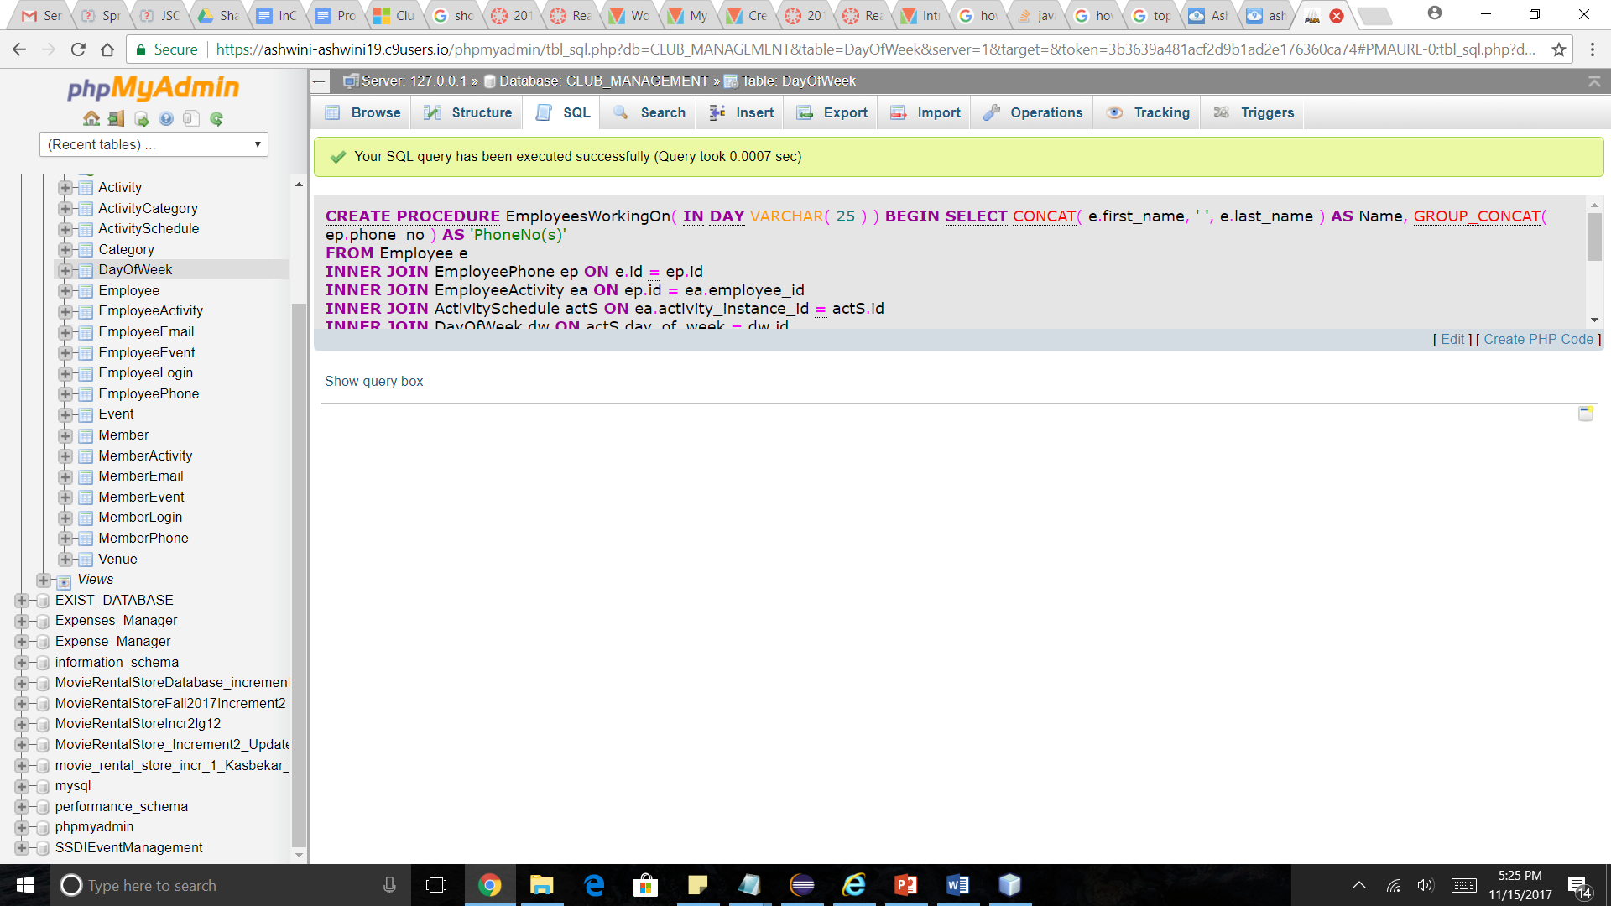

CALL EmployeesWorkingOn(

"Monday"

)

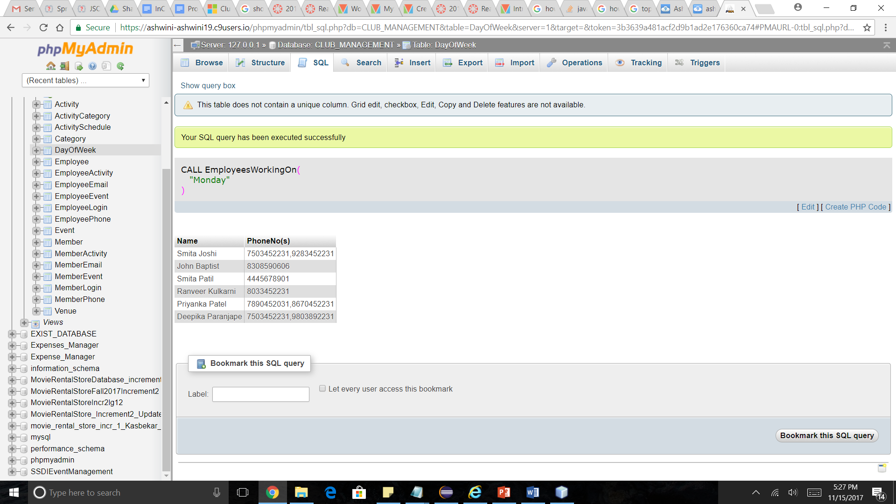

Procedure to find member names and phone numbers for a particular activity

**CREATE PROCEDURE MemberDetailsForActivity( IN act_name VARCHAR( 25 ) ) BEGIN SELECT DISTINCT CONCAT_WS( ' ', m.first_name, m.last_name ) AS name,GROUP_CONCAT( DISTINCT mp.phone_no ) AS phone_no**

**FROM Member m**

**INNER JOIN MemberActivity ma ON ma.member_id = m.id**

**INNER JOIN ActivitySchedule a ON a.id = ma.activity_instance_id**

**INNER JOIN Activity act ON act.id = a.activity_id**

**INNER JOIN MemberPhone mp ON m.id = mp.id**

**WHERE act.activity_name = act_name**

**GROUP BY name;**

**END**

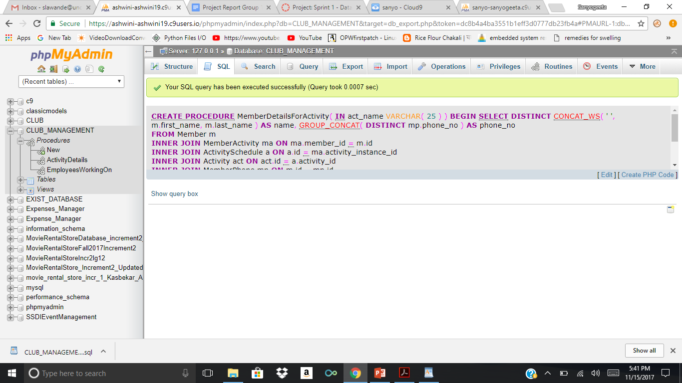

CALL MemberDetailsForActivity("Badminton")

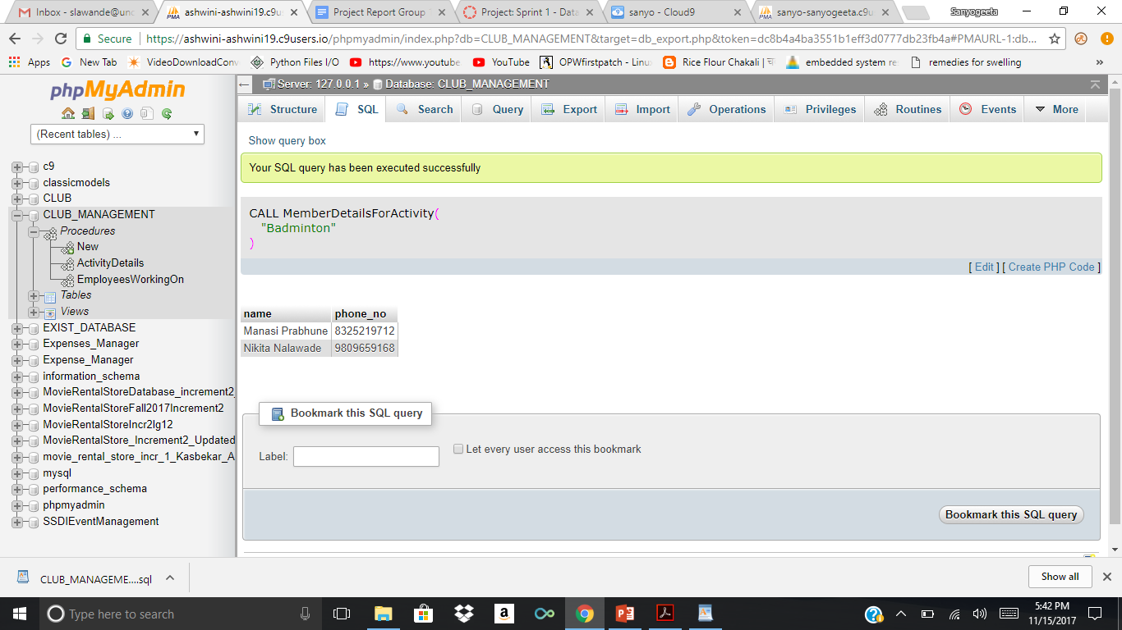

Trigger

1. To set the registration date of a new Member to current date

[**CREATE** TRIGGER before_Member_insert BEFORE](https://ashwini-ashwini19.c9users.io/phpmyadmin/url.php?url=http%3A%2F%2Fdev.mysql.com%2Fdoc%2Frefman%2F5.5%2Fen%2Fcreate-trigger.html&token=3b3639a481acf2d9b1ad2e176360ca74) [**INSERT**](https://ashwini-ashwini19.c9users.io/phpmyadmin/url.php?url=http%3A%2F%2Fdev.mysql.com%2Fdoc%2Frefman%2F5.5%2Fen%2Finsert.html&token=3b3639a481acf2d9b1ad2e176360ca74) **ON** Member

**FOR** each

**ROW**

**BEGIN**

[**SET**](https://ashwini-ashwini19.c9users.io/phpmyadmin/url.php?url=http%3A%2F%2Fdev.mysql.com%2Fdoc%2Frefman%2F5.5%2Fen%2Fset.html&token=3b3639a481acf2d9b1ad2e176360ca74) new.reg_date [=](https://ashwini-ashwini19.c9users.io/phpmyadmin/url.php?url=http%3A%2F%2Fdev.mysql.com%2Fdoc%2Frefman%2F5.5%2Fen%2Fcomparison-operators.html%23operator_equal&token=3b3639a481acf2d9b1ad2e176360ca74) [CURDATE](https://ashwini-ashwini19.c9users.io/phpmyadmin/url.php?url=http%3A%2F%2Fdev.mysql.com%2Fdoc%2Frefman%2F5.5%2Fen%2Fdate-and-time-functions.html%23function_curdate&token=3b3639a481acf2d9b1ad2e176360ca74)( ) ;

**END**

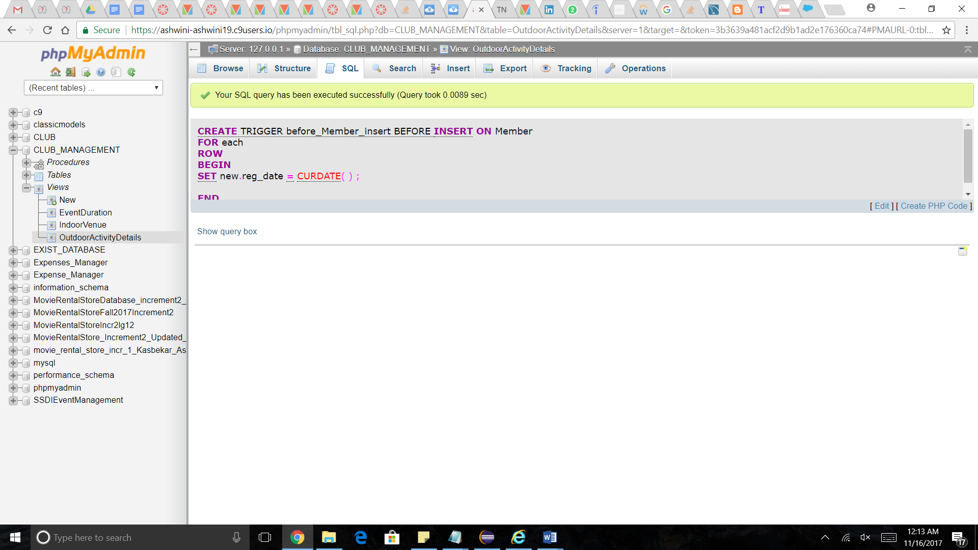

[**INSERT**](https://ashwini-ashwini19.c9users.io/phpmyadmin/url.php?url=http%3A%2F%2Fdev.mysql.com%2Fdoc%2Frefman%2F5.5%2Fen%2Finsert.html&token=3b3639a481acf2d9b1ad2e176360ca74) **INTO `Member` ( `first_name` , `last_name` , `line1` , `line2` , `city` , `state` , `zip` , `reg_date` )**

**VALUES (**

**'John', 'Snow', 'Green Park', 'Apt G', 'Charlotte', 'North Carolina', 28262, NULL**

**)**

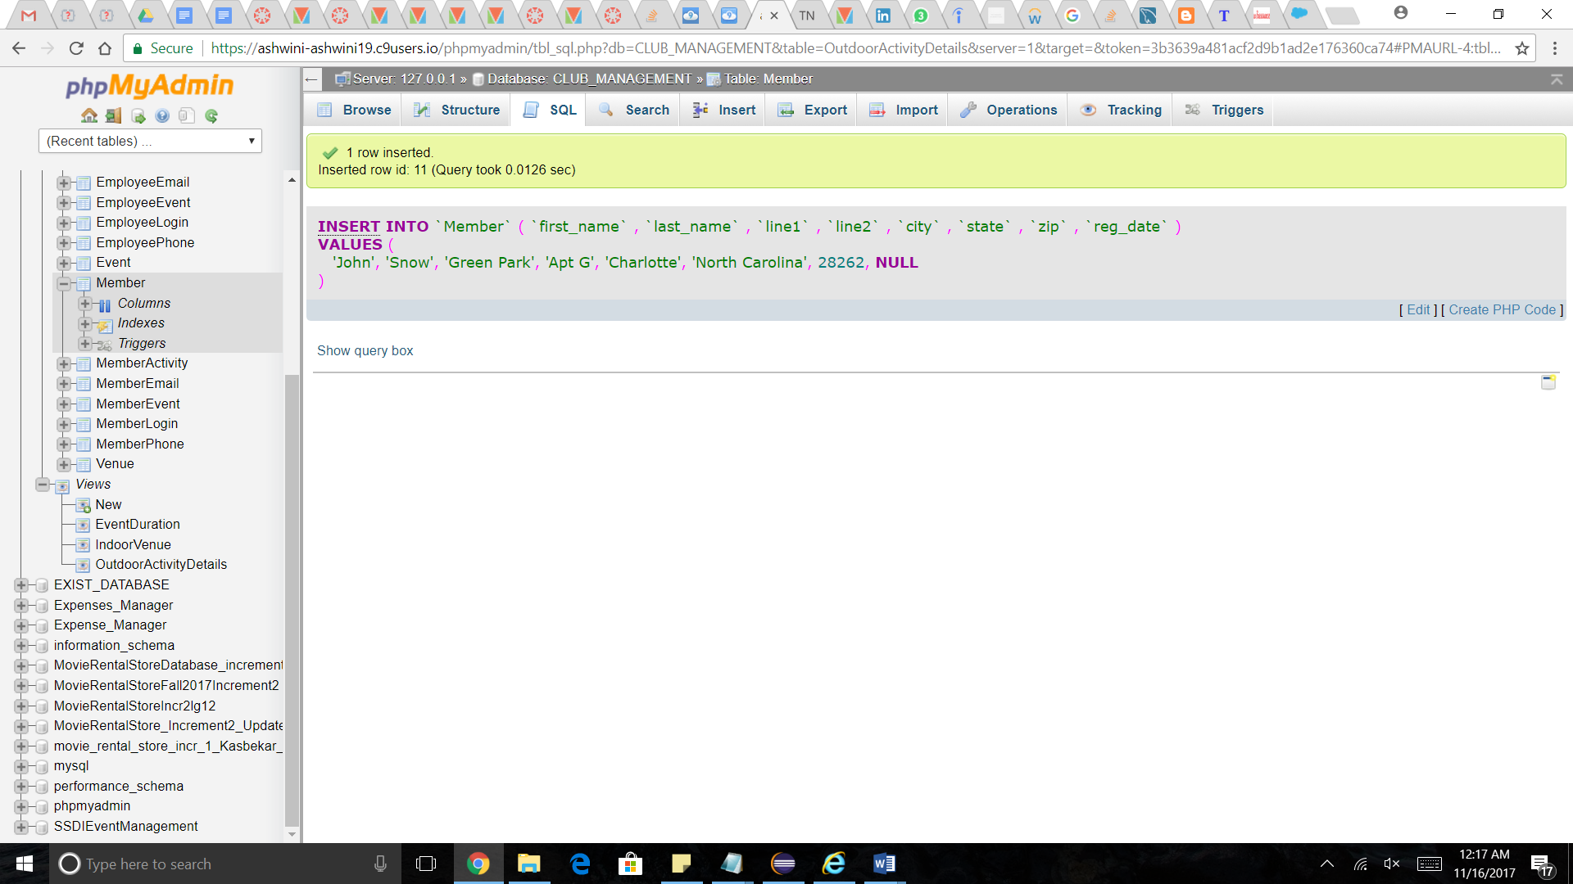

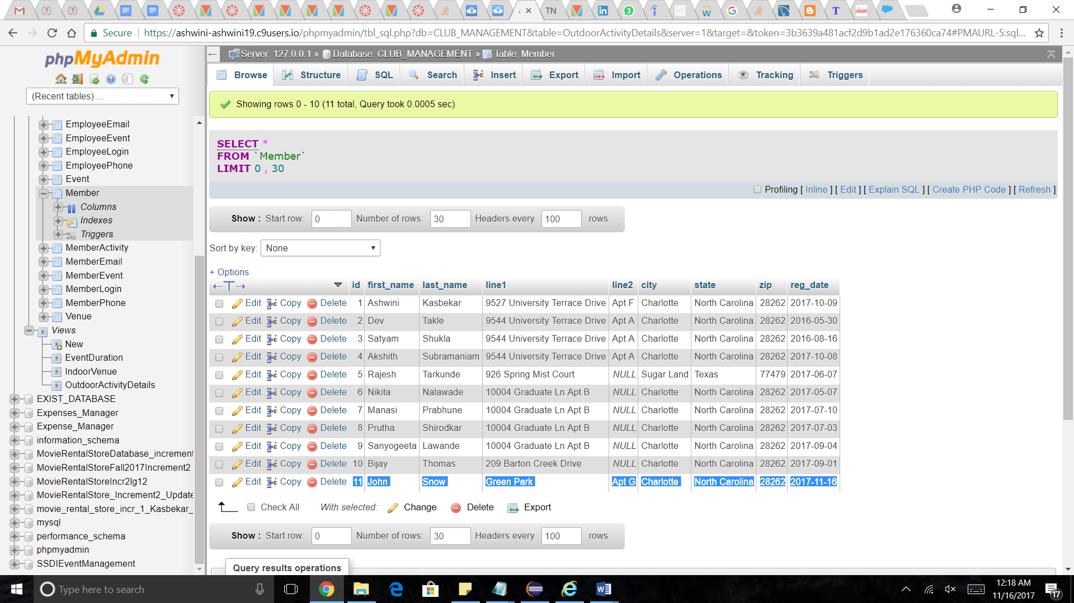

**SPRINT 3**

**REQUIREMENTS**

|  |  |
| --- | --- |
| Story ID | Story description |
| US1 | As a Manager, I want to create Activity  When the club offers a new Activity, Manager can add this activity to the database with a unique id, details and category associated with it. An Activity is a weekly recurring event at the club. |
| US2 | As a Member, I want to login using my username and password. |
| US3 | As an Employee, I want to login using my username and password. |
| US4 | As a Manager, I want to add Venue  Venue has a capacity associated with it, and it is also categorized as outdoor or indoor. |
| US5 | As a Manager, I want to build a Schedule  Manager can add club Activities to schedule with associated Venues and times. |
| US6 | As a Manager, I want to appoint Employee.  The employee is assigned to a particular activity or event based on the Schedule. |
| US7 | As a Member, I want to register for an Activity  The Member registers to the Activity based on the schedule and interest. He should be able to view the type of activities offered by the club, as well the days and times on which they are scheduled to happen. |
| US8 | As a Manager, I want to create an Event  The Event should be created with a Category so that whenever a new event is created by the club for a particular date, members can register for it. |
| US9 | As a Member, I want to request an Event. |
| US10 | As a Member, I want to book a Venue for my Event. |
| US11 | As a Manager, I want to approve Event requested by Member  The Event is added to Event Schedule after it has been approved. |
| US13 | As a Manager, I want to assign Inventory to an Activity. |
| US14 | As a Manager, I want to assign Inventory to an Event. |

**CONCEPTUAL DESIGN**

Entity: **Activity**

Attributes:

activity_name

category

Entity: **DayOfWeek**

Attributes:

day_of_week

Entity: **Employee**

Attributes:

ename [composite]

first_name

last_name

address [composite]

line1

line2

city

state

zip

email [multi-valued]

phone_no [multi-valued]

Entity: **Venue**

Attributes:

venue_name

location_type

opening_time

closing_time

capacity

Entity: **Schedule**

Attributes:

day

time

Entity: **Member**

Attributes:

member_name [composite]

first_name

last_name

address [composite]

line1

line2

city

state

zip

email [multi-valued]

phone_no [multi-valued]

reg_date

Entity: **Category**

Attributes:

category_name

Entity : **Event**

Attributes :

event_name

event_date

start_at

end_at

venue

Entity : **Inventory**

Attributes :

item_name

item_quantity

Relationship: **Member** registers for an **Activity**

Cardinality: Many to Many

Participation:

Member has partial participation

Activity has partial participation

Relationship: **Activity** has **Venue**

Cardinality: Many to Many

Participation:

Activity has total participation

Venue has partial participation

Relationship: **Activity** is added to **Schedule**

Cardinality: Many to One

Participation:

Activity has partial participation

Schedule has partial participation

Relationship: **Employee** manages an **Activity**

Cardinality: Many to Many

Participation:

Activity has total participation

Employee has partial participation

Relationship: **Activity** has **Category**

Cardinality: Many to Many

Participation:

Activity has total participation

Category has partial participation

Relationship: **Member** creates **Event**

Cardinality: One to Many

Participation:

Member has partial participation

Event has partial participation

Relationship: **Event** has **Venue**

Cardinality: Many to One

Participation:

Event has total participation

Venue has partial participation

Relationship: **Employee** manages **Event**

Cardinality: Many to Many

Participation:

Employee has partial participation.

Event has total participation.

Relationship: **Employee** manages **Event**

Cardinality: Many to Many

Participation:

Employee has partial participation.

Event has total participation.

Relationship: **Activity** has **Inventory**

Cardinality: Many to Many

Participation:

Inventory has partial participation.

Activity has total participation.

Relationship: **Event** manages **Inventory**

Cardinality: Many to Many

Participation:

Inventory has partial participation.

Event has total participation.

Note:

1. Activity_name and Activity_id is the name and id of activity of a particular Category (for ex. Badminton (with id 1) comes under category Sports).
2. Activity_instance_id is the id for a particular activity with a Schedule and Venue

(ex. Activity Badminton taking place on Monday during 4:00 to 5:00 at Court1 will have activity_instance_id as 1 likewise Activity Badminton taking place on Tuesday during 5:00 to 6:00 will have activity_instance_id as 2 etc ). Members register for a particular activity_instance and Employees are assigned for a particular activity_instance

3. Manager is the creator of Events organized by Club.

**LOGICAL DESIGN**

Table: **Activity**

Columns:

id

activity_name

Primary key justification: id is unique for every activity

Highest normalization level: 4NF

Indexes:

Index 1: clustered

Columns: id

Justification: Various joins on the Activity table will use id

Queries like find the activities scheduled on Monday etc. will require joins on Activity

Index 2: non-clustered

Columns: activity_name

Justification: A query like “List members registered for Swimming” will require a search on the Activity table based on activity name.

Table: **DayOfWeek**

Columns:

id

day_of_week

Primary key justification: id is unique to identify a particular day

Highest normalization level: 4NF

Indexes:

Index 1: non-clustered

Columns: day_of_week

Justification:

Queries like find the activities scheduled on Monday etc. will require joins on DayOfWeek table.

Table: **Employee**

Columns:

id

first_name

last_name

line1

line2

city

state

zip

Indexes:

Index 1: clustered

Columns: id

Justification: Various joins on the Employee table will use id

Queries like find the Employees scheduled to work on Monday etc. will require joins on Employee table

Index 2: non-clustered

Columns: last_name

Justification: Queries like searching for a particular employee’s details based on their name would yield a search with an efficiency of the number of employees with the same last name.

Primary key justification: id is unique for every employee

Highest normalization level: 2NF

Justification : state and city are functionally dependent on zip, however storing the state and city for every zip would consume extra space so the table is kept in 2NF.

Table: **EmployeePhone**

Columns:

id[foreign_key; references id in Employee]

phone_no

Primary key justification: id and phone_no together will be unique

Highest normalization level: 4NF

Index 1: non-clustered

Columns: id

Justification: Retrieval of employee phone numbers will be efficient. A query like “give the phone numbers of employees working on Monday” is an example where this performance is useful.

Table: **EmployeeEmail**

Columns:

id[foreign_key; references id in Employee]

email

Primary key justification: employee_id and email together will be unique

Highest normalization level: 4NF

Index 1: non-clustered

Columns: id

Justification: Retrieval of employee emails will be efficient. A query like “give the email addresses of employees working on Monday” is an example where this performance is useful.

Table: **Member**

Columns:

id

first_name

last_name

line1

line2

city

state

zip

reg_date

Primary key justification: id is unique for every member

Highest normalization level: 2NF

Justification : state and city are functionally dependent on zip, however storing the state and city for every zip would consume extra space so the table is kept in 2NF.

Index 1: clustered

Columns: id

Justification: Various joins on the Member table will use id

Queries like find the Members registered for a particular Activity etc. will require joins on Member table

Index 2: non-clustered

Columns: last_name

Justification: Queries like searching for a particular Member’s details based on their name would yield a search with an efficiency of the number of Members with the same last name.

Table: **MemberPhone**

Columns:

id [foreign key; references id from Member]

phone_no

Primary key justification: member_id is unique for every member

Highest normalization level: 4NF

Index 1: non-clustered

Columns: id

Justification: Retrieval of member phone numbers will be efficient. A query like “give the phone numbers of members who are registered for Swimming” is an example where this performance is useful.

Table: **MemberEmail**

Columns:

id [foreign key; references id from Member]

email

Primary key justification: member_id and email together will be unique

Highest normalization level: 4NF

Index 1: non-clustered

Columns: id

Justification: Retrieval of member email addresses will be efficient. A query like “give the email addresses of members registered for more than 5 years” is an example where this performance is useful.

Table: **Category**

Columns:

id

category_name

Primary key justification: id is unique for every category

Highest normalization level: 4NF

Index 1: non-clustered

Columns: category_name

Justification: Queries like display the activities belonging to a particular activity for example “Sports”

Table: **Venue**

Columns:

id

venue_name

location_type

opening_time

closing_time

capacity

Primary key justification: id is unique for every venue

Highest normalization level: 4NF

Index 1: clustered

Columns: id

Justification: Various joins on the Venue table will use id of the Venue table. Queries like find the Venues where a particular Activity or Event is taking place

Table: **ActivitySchedule**

Columns:

id

day_of_week [foreign_key; references id from DayOfWeek]

start_at

end_at

activity_id [foreign key; references id from Activity]

venue_id [foreign key; references id from Venue]

Primary key justification: id is uniquely generated id to indicate a specific instance of an activity

This table represents activity, Schedule and Venue relationship.

Highest normalization level: 4NF

Index 1: clustered

Columns: id

Justification: id will be used in queries like list employees working on Mondays which requires a join between EmployeeActivity, ActivitySchedule and Activity.

Index 2: non-clustered

Columns: day_of_week

Justification: it can be used for queries like “list all activities taking place on Monday” which requires a join between Activity table and Day_of_week table

Table: **EmployeeActivity**

Columns:

employee_id [foreign key; references id from Employee]

activity_instance_id [foreign key; references id from ActivitySchedule]

Primary key justification: Since Employee and Activity have a many to many relationship we use a cross-reference approach, hence employee_id and activity_instance_id together form a primary key

Highest normalization level: 4NF

Index 1: clustered

Columns: activity_instance_id

Justification:

A query like list the employees working for a particular activity on a particular day would benefit from an index on activity_instance_id

Table: **ActivityCategory**

Columns:

activity_id [foreign key; references id from Activity]

category_id [foreign key; references id from Category]

Primary key justification: Since Activity and Category have a many to many relationship we use a cross-reference approach, hence activity_id and category_id together form a primary key

Highest normalization level: 4NF

Table: **MemberActivity**

Columns:

member_id [foreign key; references id from Member]

activity_instance_id [foreign key; references id from ActivitySchedule]

Primary key justification: Since Activity and Member have a many to many relationship we use a cross-reference approach, hence member_id and activity_instance_id together form a primary key.

Highest normalization level: 4NF

Index 1: clustered

Columns: activity_instance_id

Justification:

A query like list the members registered for a particular activity on a particular day would benefit from an index on activity_instance_id

Table: **MemberLogin**

Columns:

member_id [foreign key; references id from Member]

pass

Primary key justification : member_id can uniquely define a row

Highest normalization level: 4NF

Index 1: clustered

Columns: member_id

Justification: For quicker login into the account

Table : **EmployeeLogin**

Columns:

employee_id [foreign key; references id from Employee]

pass

Primary key justification : employee_id can uniquely define a row

Highest normalization level: 4NF

Index 1: clustered

Columns: employee_id

Justification: For quicker login into the account

Table : **Event**

Columns:

id

name

start_time

end_time

event_date

venue_id[foreign key; references id in Venue]

Primary key justification :id is unique for every venue

Highest normalization level: 4NF

Index 1: non-clustered

Columns: venue_id, date

Justification: For queries like listing the event time-table of a particular Venue, this results in faster retrieval.

Table: **MemberEvent**

Columns:

member_id[foreign key; references id in Member table]

event_id[foreign key;references id in Event table]

Primary key: member_id and event_id are unique together

Highest normalization level: 4NF

Index 1: non-clustered

Columns: event_id

Justification: For queries like finding the member who created the Event.

Table: **EmployeeEvent**

Columns:

employee_id[foreign key; references id in Employee table]

event_id[foreign key;references id in Event table]

Primary key: employee_id and event_id are unique together

Highest normalization level: 4NF

Index 1: non-clustered

Columns: event_id

Justification: For queries like finding the Employees who are assigned to the Event.

Table: **Inventory**

Columns:

id

item_name

quantity

Primary key:id uniquely defines Inventory item

Highest normalization level: 4NF

Index 1: clustered

Columns: id

Justification: Queries on ActivityInventory will require joins on Inventory, thus indexing id will give us faster retrieval. Example: List items checked out for <Activity instance>

Index 2: non-clustered

Columns: item_name

Justification: For queries like listing the number of chairs in inventory

Table : **ActivityInventory**

Columns:

item_id [foreign key; references id in Inventory table]

activity_instance_id [foreign key; references id in ActivitySchedule table]

quantity

Primary key:item_id and activity_id are unique together

Highest normalization level: 4NF

Index 1: clustered

Columns: activity_instance_id

Justification: Index on activity_instance_id will make queries like finding the items that were assigned to a particular Activity efficient.

Table : **EventInventory**

Columns:

item_id [foreign key; references id in Inventory table]

event_id [foreign key; references id in Event table]

quantity

Primary key: item_id and event_id are unique together

Highest normalization level: 4NF

Index 1: clustered

Columns: event_id

Justification: Queries like finding the items assigned to an Event will become efficient due to this index.

# 